RESEARCH PAPER

Table of Contents
1. Introduction 3
2. Project description 4
3. Methodology 5
3.1. Desk research 5
3.1.1. Reasons and method for implementation 5
3.1.2. Results received 5
3.2. Questionnaires 27
3.2.1. Analysis of the obtained data 27
3.2.2. Comparison of data by country 55
3.3. Interviews 69
3.3.1. Target group and list of questions asked 69
3.3.2. The most important notes from the interview 70
3.3.3. Comparison of data by country 80
4. Conclusions 83
4.1. Summary of the main findings 83
4.1.1. Slovakia 83
4.1.2. Slovenia 84
4.1.3. Hungary 85
4.1.4. Croatia 86
4.2. Confirmation or refutation of the hypothesis 86
5. Recommendations 88

Introduction

The Research paper was conducted as part of the project activities of the ERASMUS+ SPORT project "CSR for Parasport".
Data collection was carried out in two phases. The first phase was desk research which examined whether there are already CSR practices that fund sports for people with disabilities. The second phase of the research was related to field research which took the form of questionnaires and interviews. After collecting data, it was important to analyse and process the obtained data. Quantitative data were statistically analysed and presented as National reports based on every country individually and after that 20 participants from all of the countries were selected and analyzed in a Research paper to get conclusions and recommendations for possible future improvements.
The results will be produced and published in English but will also be translated and published into the languages of all partner countries at project partner websites (Croatian, Hungarian, Slovak, and Slovenian).
The Research report has its main hypothesis, which research will try to prove or disprove.
The main hypothesis is: „Collaborative CSR partnership between companies and sports organizations has an increasingly positive influence on Parasport.”

Project description

The consortium identified several needs regarding the economic and social status of athletes with disabilities and Sports organizations for People with Disabilities (SOPD) in partner countries: financial support of parasport from the state and long-term support from the business sector, more sports programs for people with disabilities (PWD) and more educated trainers in the field of sport for PWD, more children and youth athletes in parasport, equal access for children with disabilities to participate in play, recreation and school system, better media coverage of parasport, more physically active PWD; better equipment, infrastructure and infrastructural access to sporting venues for PWD.
Project results are:
- Research of fund-raising activities into SOPD with recommendations of good practices,
- Educational materials “Train the trainer” and “Train the end users”,
- Guidelines for funding SOPD, and
- Piloting and Evaluation of educational materials.
Project results will increase the competencies and capacity of SOPD through good governance with a special focus on fundraising activities by building bridges for long-lasting partnerships with CSR companies. A long-term benefit for National Paralympic Committees (NPC) can be the creation of a long-term partnership in which companies will be more inclusive in their CSR policies (eg: employment of athletes with disabilities, opportunities to finance sports for young people with disabilities, etc.). By attracting more resources in SOPD from CSR companies, greater involvement in sports will be achieved, which will result in better sports results. Better results will attract even greater investments and contribute to long-term partnerships. Even though the core activities of the project will be implemented in 4 countries, because of the wide impact of partnering with NPC, the dissemination strategy has been designed not for promoting the project in only 4 countries, but to transfer its results to the EU level, thus enabling impact as wide as possible.

Methodology

The research will be conducted in three ways: desk research, questionnaires and interviews. Each method of research aims to obtain as realistic and objective information as possible, on the basis of which comprehensive conclusions will be drawn at the end and recommendations will be made for the development of Parasport in the observed area.

Desk research

Desk research is a type of research that is conducted based on already available published documents/research, that is, it is a type of secondary research.

3.1.1. Reasons and method for implementation

Desk research was conducted to reach certain conclusions based on existing data. Each participating country conducted desk research at the national level to analyze the legal framework regulating not only the rights of persons with disabilities but specifically the rights of para-athletes. Also, an analysis of the financing of parasports was carried out to obtain a comparison between the financing of sports and parasports. In the end, each country listed the most important projects in the field of parasports that they implement at the national level.
The goal of the desk research was to study the same components in all participating countries so that later they could be studied together and obtain data that can be compared with each other and see the real situation, both in these countries and in the observed area.

3.1.2. Results received

The main emphasis of the desk research was on the financing of Parasport since this is one of the main topics that appear in every country that has developed Parasport. Each participating country has researched the financing of Parasport, and the results are presented below.

3.1.2.1. Slovakia

In Slovakia, sports currently account for 0.76% of gross domestic product and 0.44% of total employment, which places it among the least economically significant sectors across all EU member countries. The reasons for this state of affairs need to be primarily sought in non-systematic funding, which not only hinders the development of professional-level sports but also significantly limits the development of sports for all and sports activities for children and youth.
The limited options for setting development indicators for sports associations are the result of the current valid three-pillar financing system, none of which provides a stable volume and conditions for both ordinary and capital financial resources. The share of current public expenditure as a percentage of gross domestic product is lower in Slovakia than in the least developed EU countries, which directly affects the volume of investments. The investment share as a percentage of gross domestic product reaches only 56% of the EU average. As a result of the low volume of investments, the investment debt in sports infrastructure is significantly deepening, currently reaching the limit of 450 million EUR at current prices, while the unspent EU funds since 2004 amount to 405 million EUR. The characteristics of Slovak sports are unprecedented within the EU countries, raising the question of whether sports are currently perceived as a matter of public interest or just a marginal concern of enthusiasts who try to keep up with developed Europe through voluntary work. Sports, however, are one of the most effective areas of public funding. Currently, one euro of public resources can generate 2.79 euros of gross domestic product growth, with a potential of up to 4 euros. In terms of employment development, the sports industry can sustainably create one job for every two-thirds of the average investment incentives for direct foreign investment. Not to mention that the development of sports in Slovakia will directly and positively influence other areas such as tourism, culture, and more. At the same time, it has a direct impact on the development of not only large cities and industrial regions but especially rural and transitional regions.
72% of the population in Slovakia does not engage in any general sports activities at all, as they only do them occasionally. According to a 2017 Special Eurobarometer study, 49% of the population in Slovakia does not engage in any physical activity. There are 166 coaches per 100,000 inhabitants in Slovakia. Based on a 2016 European Commission study, Slovakia has significantly fewer coaches per hundred thousand inhabitants compared to the average of the surveyed countries, despite a growing trend.
The average growth rate of public expenditure on sports from 2015 to 2019 is 14%. The financing of sports from the state budget is primarily regulated in the fifth part of the Sports Act. Slovakia spent an average of 0.4% of its total public expenditure on sports from the state budget during the years 2014-2018. According to Eurostat statistics, this is lower than the average of 0.7% for the 28 EU countries.
36% of primary and secondary schools in Slovakia do not have a gymnasium. In 2017, the Ministry of Education analyzed gymnasium conditions in schools, with the worst conditions found in the Nitra and Prešov regions.
Strategic and legislative documents defining the development and importance of sports for society at the national level
At the national level, there is currently no comprehensive document that has the ambition to define the basic pillars of Slovak sports, characterize the horizontal priorities of the sports movement, and specify long-term financing for sports.
The current system of sports financing is based on three sources: public sources, private sources, and own sources. Public sources include the budgets of the Ministry of Education, Science, Research, and Sport of the Slovak Republic, the Ministry of Defense of the Slovak Republic, and the Ministry of the Interior of the Slovak Republic. It also includes the budget of the Office of the Government of the Slovak Republic, EU funds, 2% taxes on the income of individuals and legal entities, contracts for advertising activities of state-owned companies, production and broadcasting of sports in public media, proceeds from sports betting on results, budgets of cities, municipalities, and self-governing regions, and budgets of companies in which cities, municipalities, and self-governing regions hold shares.
Private sources include donations from individuals and legal entities, contracts for advertising activities, monetary and non-monetary contributions for services provided by sports entities, proceeds from charitable lotteries, and the value of volunteer work in sports. Own sources include the income of a person engaged in sports, the income of the legal representative of a person engaged in sports, and income from membership fees for sports organizations.
The main objectives of financing Slovak sports are to finance professional sports and to finance sports for all. The principle of financing professional sports lies in the regular allocation of contributions to recognized sports from the state budget. This is based on the notion that sports are more beneficial to Slovak society and the presentation of Slovakia to the world when they achieve better results and attract more children to regular sports activities. In simplified terms, the share of recognized sports depends on three basic parameters: sports success, interest in sports, and membership base up to the age of 23.
The principle of financing sports for all is based on the fact that its socio-economic significance is directly proportional to the number of people engaging in regular physical activity, regardless of their motives (health, leisure, entertainment, beauty, influence, income). Financing sports for all is an original competence of local self-government. The state budget primarily supports the education of children and youth in developing lasting competence in physical activity. The main drawback of the current model of financing Slovak sports is its high instability.
The first cause of instability is the ambiguous identification of specific public funding sources. The second cause is the lack of a mechanism for valorizing the volume of financial resources from public sources. As a result of the high instability of the model, there is a huge and continually growing investment debt, which hinders the development of individual sports disciplines and sports infrastructure, and acts as a slowing factor for its digitization and commercialization.

Sponsorship Agreement
The sponsorship agreement is defined in the Sports Act in §50 and §51 as follows: By a sponsorship agreement, the sponsor undertakes to provide direct or indirect monetary or non-monetary benefits to an athlete, sports expert, or sports organization who are a member of a national sports association, national sports organization, or international sports organization.

The sports sponsorship agreement combines a purposeful gift and advertising, primarily intended to support the sponsored sports activity (90%), and secondarily intended to promote the name or brand of the sponsor (10%). The sponsor has the right to request information about the use of the sponsorship, and the sponsored party is obliged to provide it promptly. The Institute of the sponsorship agreement represents transparent financing of sports, which includes public control in the form of:

In 2016, the Sports Act was adopted in Slovakia, and after a sufficient period, we can summarize its advantages and disadvantages. The legal framework for sports defined by the Sports Act represents a solid framework for the future functioning of the sports movement in Slovakia. It reflects trends within the European space, and overall, it can be stated that its adoption has been very beneficial for Slovak sports as it introduced systematicity and several positive elements into the sports movement. One of the most important aspects is the increase in the volume of financial resources and their eligibility based on defined criteria. The Act formalized labor relations in the field of sports and also established important control bodies in the sports movement. The establishment of the Sports Support Fund and the Sports Information System can be regarded as positive developments. However, after five years of experience with the use of the Sports Act, there are numerous comments and proposals for improvement. These proposals require additional amendments to certain parts of the law in areas identified as problematic based on a thorough analysis of the current situation. However, any changes must be preceded by a broad professional discussion involving all stakeholders. An appropriate tool for such a discussion may be an expert working group established in the next stage of the project for the development of a strategy for Slovak sports.
Advantages and improvements brought by the Sports Act include:
- Establishing fundamental concepts for organized sports
- Increased and stabilized finances for national sports associations and umbrella organizations
- Defining new contractual relationships in sports
- Institutions established by the Sports Act:
- Disciplinary Commission is a body for resolving sports disputes
- Chief Sports Inspector
- Slovak Anti-Doping Agency
- Initiation of the Sports Information System

On the other hand, the Act has also faced criticism regarding its effectiveness, mainly for the following reasons:
- Defining a large number of obligations for sports organizations
- Duplicate obligation for organizations to disclose data in the Sports Information System and on their website
- Unclear definition of obligations for entities operating in sports
- Debated retention of "restrictions" in the grant formula
- Multiple sanctions for a violation of the law by a subject
- Loss of eligibility for recipients of public funds
- Abolition of the certificate of recognition as a national sports association
- Administrative offense
- Lack of transparency in the law with the possibility of various interpretations.

When analyzing the redistribution of resources based on the Sports Act, it is necessary to note the absence of systematic funding for sports for the disabled. On one hand, this particular part of the sports ecosystem is allocated a portion of financial resources. However, these resources are not subsequently allocated through a formula but based on imprecise and immeasurable indicators. For this reason, it would be appropriate to apply the allocation of financial resources to individual types of sports activities through a transparent formula similar to the currently recognized sports. Of course, it is not possible to directly apply the formula for recognized sports to the allocation of resources for disabled athletes. This area should undergo comprehensive adjustments, which must be preceded by a broad professional discussion.

In comparison to other countries, Slovakia allocates the least amount of financial resources to sports from the state budget (in absolute and percentage values). This calculation has also been confirmed when comparing the price levels in the respective countries. Sports funding in the conditions of the Slovak Republic is secured from multiple sources. The Ministry of Education and local self-governments play the most important role, with the share of self-governments in public sports expenditures in the Slovak Republic being more than 50% during the observed period. Since 2020, the Sports Support Fund has become a significant source of sports funding, established to meet the urgent need for sports infrastructure development. State support for sports has historically been divided among several ministries, specifically the Ministries of Education, Defense, and Interior. This division in practice brings positive aspects (such as multi-source financing for individual sports) but also negative aspects (such as complex communication and administrative duplication). The eligible contribution for recognized sports associations is determined based on a calculation using a multi-criteria grant formula and transparently based on pre-known parameters. However, the actual amount of the contribution is limited by "restrictions" that prolong subjectively set values before the formula's implementation, disadvantageous to the majority of sports associations (based on the number of voting rights and the proportion of membership base). Other problematic factors include the calculation of domestic or international interest in sports, which is derived from disputed parameters, and the imbalance or a strong focus on elite sports. As a result of this "imbalance," a small group of elite athletes influences the overall amount of the grant. It should be mentioned that activities are being carried out to adjust and improve these parameters.

Sports infrastructure has a high level of investment debt and does not meet the requirements for basic sports training, organizing sports events, active leisure activities, or barrier-free access for all athletes. The infrastructure is also characterized by high energy demand and is not in line with the principles of sustainability. The unfavorable state is compounded by the absence of a national register of sports infrastructure in Slovakia. A clear definition of priority areas for infrastructure development or renewal is also missing. The creation of the register is currently in progress, with completion expected in 2021. Several infrastructure projects have been implemented in recent years. Unfortunately, they were not approached systematically in terms of preparation and implementation. Information on potential positive impacts on youth or sports results is also lacking. The establishment of the Sports Support Fund marks a significant milestone in this regard.

3.1.2.2. Slovenia

The review of the financing parasport in Slovenia is based on the currently valid Sports Act. The Sports Act defines the public interest in the field of sports, the mechanisms for its implementation, the bodies responsible for it, and the conditions for performing professional work in sports, the rights of sportsmen and women, public sports facilities and areas for sports in nature, sports events, collections data and control in the field of sports. Special attention is paid to parasport (sport for disabled), which is defined in the law with the definition: sports for the disabled are all forms of sport that disabled people engage in outside the school system.

Rules on the co-financing of the implementation of the annual sports program at the state level

These regulations determine the criteria for co-financing the following programs and areas of the LPŠ:
sports programs:
- leisure sports education of children and youth,
- physical education of children and youth with special needs,
- extracurricular sports activity,
- physical education of children and youth oriented towards high-quality and high-quality sports,
- top sport,
- sports for the disabled,
- sports recreation,
- senior sport
- investments in sports facilities and areas for outdoor sports,
- development activities in sports:
- education, training and professional development of sports professionals,
- status rights of athletes and professionals in sports and professional support for programs,
- sports publishing,
- scientific research activity in sports,
- information and communication technology in the field of sports,
- organization in sports,
- sports events and sports promotion:
- sports events,
- public information about sports,
- sports heritage and museum activity in sports,
- social and environmental responsibility in sport

Subject and conditions for co-financing
Funds for top sports programs are co-financed by:
- preparations and performances of national member national teams, which include top athletes with olympic, world and international class status,
- fund for top athletes,
- awards to top athletes and professionals.

National sport federations, Slovenian Olympic Committee and the Association of Sports for the Disabled of Slovenia – Slovenian Paralympic Committee (hereinafter: NPC Slovenia) can apply for co-financing of activities from the first and third indents of the previous paragraph, and for co-financing of activities from the third indent also associations that compete in team sports.

Sports for the disabled (Parasport)
Funds for sports for disabled people are co-financed by:
- pilot programs of connecting sports and disabled and charitable societies and associations,
- national championships in the field of disabled sports.

Subject and conditions of co-financing
A contractor whose pilot program relates to mass sport for the disabled at the national level co-financed, if the organizational integration of sports, disability or humanitarian associations and federations is evident in the planning and implementation of the program.

Subject and amount of co-financing
The operation of NPC SLOVENIA as an umbrella sports organization in the field of sports for the disabled in the Republic of Slovenia is co-financed.
The following areas of operation are co-financed:
- co-financing of professional work on projects and programs of high-quality sports and sports education for children and youth, aimed at high-quality and high-quality sports,
- implementation of activities within the framework of competition projects, the bearer of which is NPC SLOVENIA: paralympic games and the deaflympics
- preparation of a proposal for criteria for a top sporting achievement of international value,
- implementation of public powers based on the law (preparation of a training program for disabled sports),
- work on projects with the aim of increasing the participation of disabled people in sports,
- establishment and operation of a system to increase the participation of disabled people in sports.
- funds for the operation of NPC SLOVENIA are determined by annual sport programs.

Subject, criteria and amount of co-financing
Preparations and participation in international multi-disciplinary sports competitions are co-financed: Olympic Games, Paralympic Games, Deaflympic Games, European Games, Mediterranean Games, World Games of non-Olympic sports branches and disciplines, European Youth Olympic Festival and Youth Olympic Games, namely:
- At a value of up to 13 points per day, in the year before the Paralympic Games and in the year of the paralympic games 20 days of preparation and participation for candidates for participation in the paralympic games are co-financed, the number of which is based on the volume of funds at the proposal of the Association for Disabled Sports Slovenia - The Paralympic Committee is determined by the Ministry. To evaluate the program, the value of the point for the programs of preparation and performances of the national member national teams is used.
- At a value of up to 13 points per day, in the year before the Deaflympics and in the year of the Deaflympics, 20 days of preparation and participation are co-financed for candidates for participation in the Deaflympics, the number of which is based on the volume of funds at the proposal of the Association for Sport of the Disabled of Slovenia - The Paralympic Committee is determined by the Ministry. To evaluate the program, the value of the point for the programs of preparation and performances of the national member national teams is used.

Pilot programs of connecting sports and disabled and charitable societies and associations

Subject of co-financing
The use/rental of sports facilities and surfaces, as well as the appropriate professionally educated staff of the sports department, are co-financed for the implementation of pilot programs of connecting sports and disabled as well as charitable societies and associations.

Conditions for co-financing and amount of co-financing
Co-financing is given to a contractor whose pilot program relates to mass sport for the disabled at the national level, and the planning and implementation of the program shows the organizational integration of sports, disability and charity associations and federations.
The amount of funds for pilot programs connecting sports and disabled and charitable societies and federations is determined by annual sport programs.

Criteria for co-financing
The purpose and goal of the pilot programs, the criteria for the selection of the pilot programs of connecting sports and disabled and charitable societies and associations, and the co-financing of the pilot programs are determined in each public tender.

National championships in the field of disabled sports

Subject of co-financing
The use/rental of sports facilities and surfaces for holding national championships in the field of disabled sports is co-financed.
Conditions for co-financing
The implementation of national championships for the disabled is co-financed under the following conditions:
- the national championships for the disabled take place at the same time as the national championships of the regular program of individual sports in individual sports and at the same time as the national championships or the end of the Cup of Slovenia in collective sports;
- the individual national championship for the disabled is the only national championship for the disabled in a particular year and
- national sport federations is applying for co-financing of the state championships for the disabled, which is the holder of individual sports branches at the national level.

The evaluation of programs for the implementation of national championships in the field of sports for the disabled is done on the basis of a point system.
For the current year, the Ministry determines the point value for holding national championships in the field of disabled sports as a ratio between:
- the amount of funds specified in annual sport program, for the implementation of national championships in the field of sports for the disabled and
- the total number of points of all contractors registered for the public tender, who meet the conditions for co-financing the implementation of national championships in the field of sports for the disabled.

Olympic and paralympic medals
In the field of parasport, disabled athletes, holders of Paralympic medals and Deafllympic medals and their coaches, as determined by the Association for Disabled Sports of Slovenia - Slovenian Paralympic Committee, are paid a prize in the amount specified in the provisions of the first to the fifth paragraph inclusive of this article.

Financing parasport on local level
An analysis of the ten-year national program for sports in Slovenia showed that, on average, only eight percent of the budgeted funds for sports for disabled people were spent at the local level. This means that there are many opportunities for financing sports activities for the disabled, which both sports associations and disability associations do not take advantage of. Each year, local communities allocate significant funds for sports based on the adopted Annual Sports Program within the municipal budget. The annual program for sports distributes money according to individual areas of sports. Therefore, disability organizations must fight even before the adoption of the annual program for sports, so that disabled people's sports receive an appropriate share of funds within the program. In this case, the criteria of local communities are often linked to the large number of participation in sports programs, where it is possible to meet the criteria for financing mainly by joining consortia and combining the programs of several disability organizations into one. In doing so, associations of disabled people must adapt as much as possible to the criteria for awarding financial resources for programs and facilities at the municipal level. Another aspect of funding at the local level is the excellence criterion, which means equal status of top athletes with disabilities compared to other top athletes. Equalizing top athlete status also means additional funding for their program. Sports clubs, either those that are sports clubs for the disabled or those that have sports for the disabled integrated into their programs, must act 38 in a coordinated, unifying and proactive manner if they want to meet the criteria of the local community for funding. Due to the smaller number of disabled people in each place, which prevents organized group exercise for disabled people, in many places there is also a need to connect several local communities or sports associations together, which also means lower costs in organizing programs, which due to the nature of the programs (usually a smaller number practitioners per group) slightly more expensive.

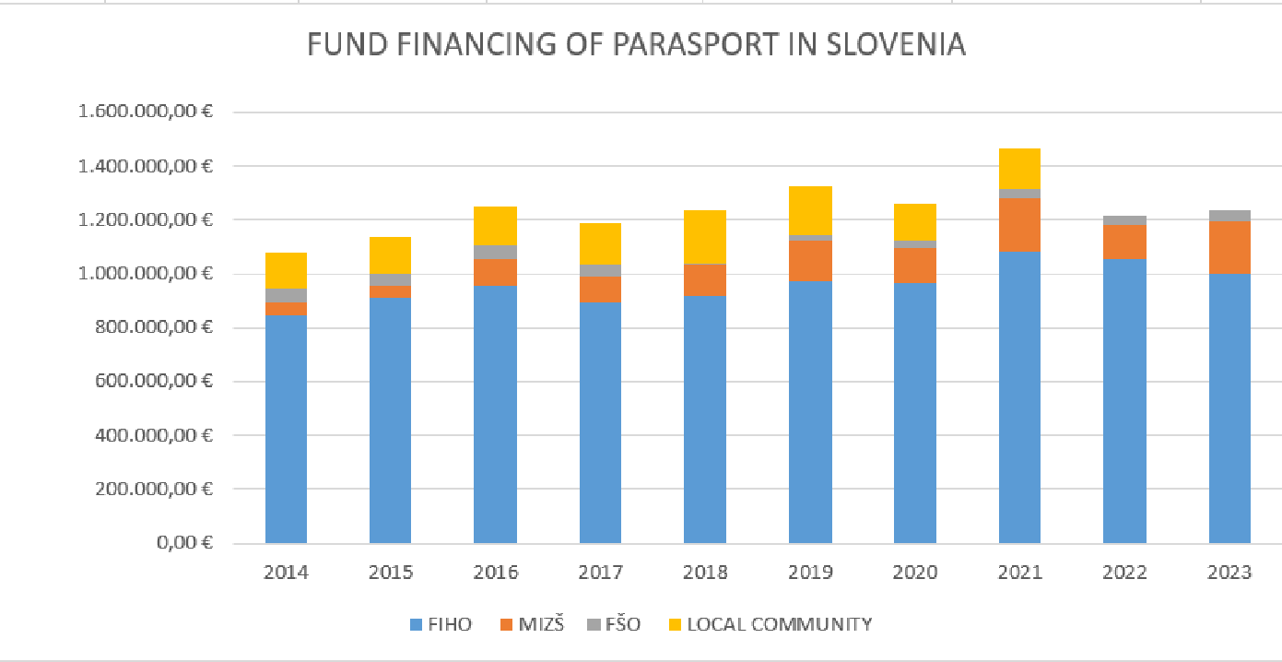

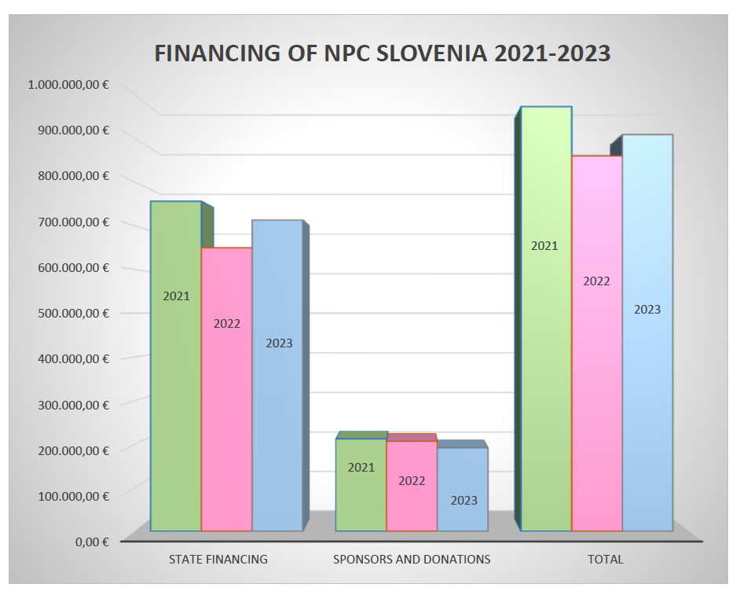
Above is a graph of financing NPC Slovenia – together with state financing and sponsoring.

3.1.2.3. Hungary

Financial situation, sponsors, CSR practices in Hungary
o Support/budget system of disabled sport: governmental support, Aladár Gerevich sport scholarship, BOM scholarship, Hungarian Sport Stars’ scholarship, governmental rewards and support of efficiency, Olympic annuity, Olivér Halassy Program – appreciation of Parasport coaches, sponsorships and donations

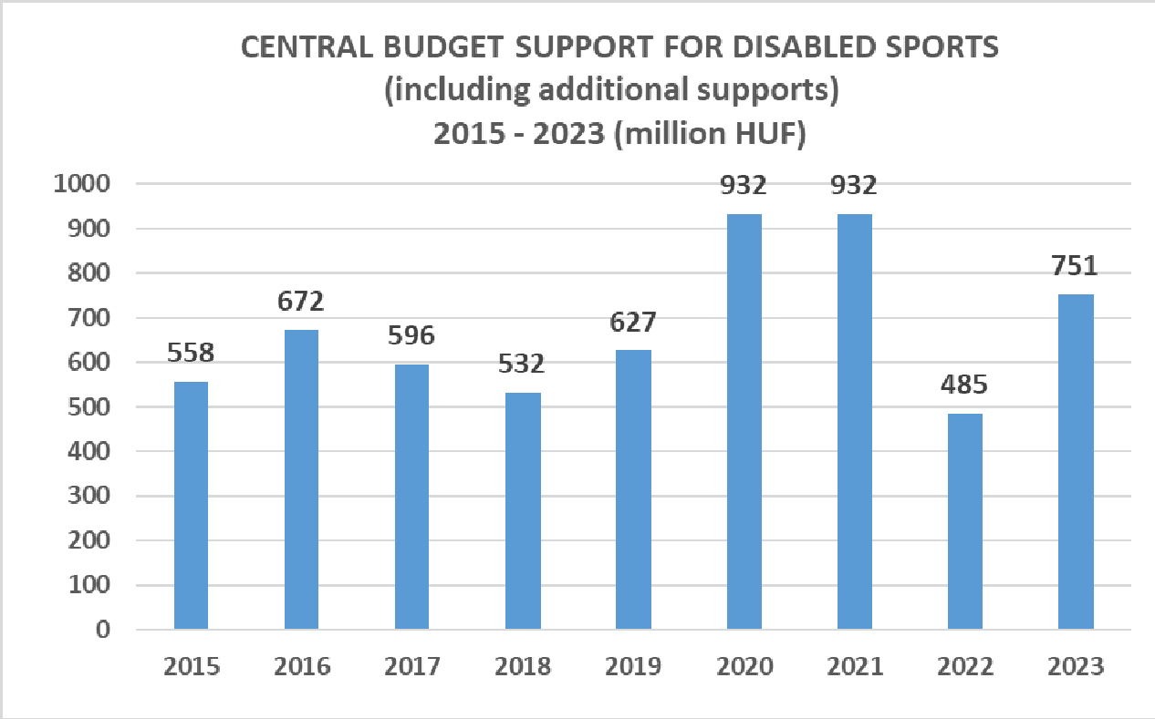
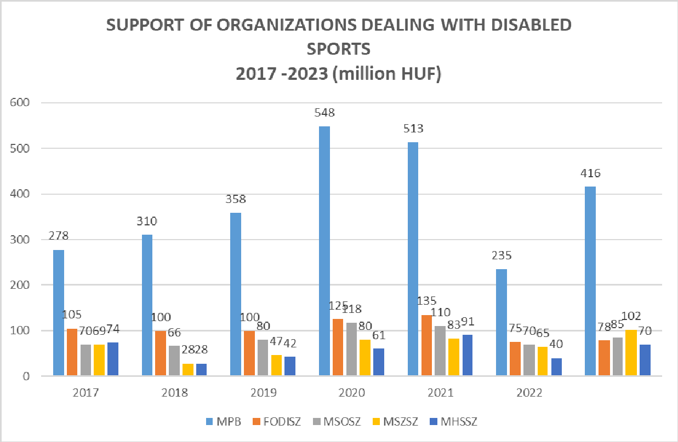
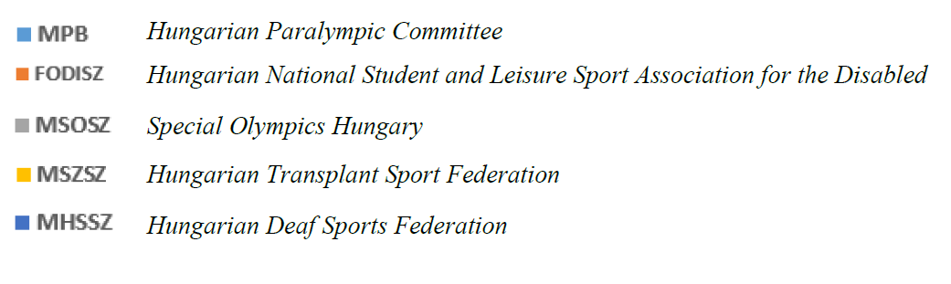

Hungarian Paralympic Committee’s budget is mainly supported by the Ministry of Defence (state sources) and sponsored by different private sources
- Companies that regularly finance and support the disabled sport: Allianz Hungary, K&H Bank, Toyota, Tisza, REHAB, BioTech USA

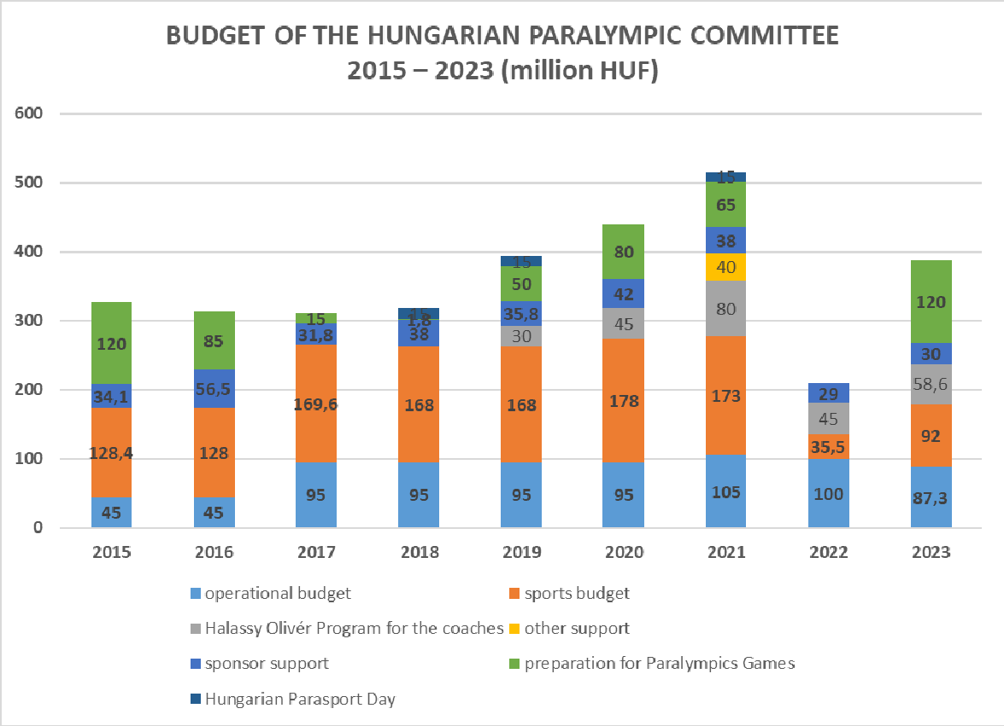

3.1.2.4. Croatia

The Republic of Croatia (in the following: the Republic of Croatia) is decorated with the name "Sports Nation", which is supported by a large number of athletes who achieve enviable results. If we take into account that in terms of the population of the Republic of Croatia it is in 26th place, sports results come to the fore even more.
The continuous achievement of top sports results would certainly not be possible without the help of umbrella sports associations and their members, who take care not only of the development of top and amateur sports, but also of the development of sports for people with disabilities and school and academic sports. Their synergistic action enables the development of numerous sports, which directly results in the expansion of the base for the development of top athletes through an increase in the number of clubs and athletes, and indirectly encourages physical activity that is beneficial for health.
The Law on Sports of the Republic of Croatia does not recognize the term "umbrella sports associations", however, with the organization of sports and the distribution of financial resources from the state budget of the Republic of Croatia, we arrive at five associations that could be considered umbrella sports associations. Sports organizations implement five separate programs, but their areas are still intertwined. The umbrella sports associations of the Republic of Croatia are: Croatian Olympic Committee (HOO), Croatian Paralympic Committee (HPO), Croatian Deaf Sports Association (HSSG), Croatian Academic Sports Association (HASS) and Croatian School Sports Association (HŠSS).
The areas of work and obligations of umbrella sports associations in the Republic of Croatia are prescribed by the Law on Sports, while the activities are mostly financed from the state budget. Below is the financing of umbrella sports associations from 2012 to 2022.

Table 1: Financing of umbrella sports associations - 2012-2022. years.
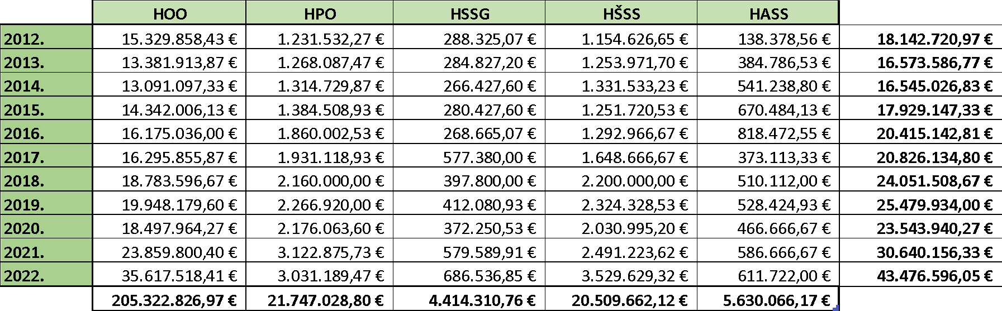
Source: Ministry of tourism and sport Croatia
Table 1 shows the financing of umbrella sports associations of the Republic of Croatia over a period of ten years. Looking at the table, we see that the largest amount of funds went to finance the activities of the Croatian Olympic Committee (HOO), while the least amount of budget funds was allocated to the activities of the Croatian Sports Association of the Deaf (HSSG). Also, if we compare the years, we can see two oscillations, or declines. The first occurred in 2013 compared to 2012. The financial resources reserved for sports in 2012 were slightly more than 1,500,000.00 euros more than the financial resources in 2013. The reason for this is attributed to the fact that 2012 was the Olympic year and it was necessary to allocate more financial resources to cover the costs of the athletes going to the Olympic and Paralympic Games. The second oscillation, or decline, was recorded in 2020, when the sports budget was reduced by a little less than 2,000,000.00 euros. The reason for this was attributed to the global pandemic caused by COVID-19 when there was a ban on holding sports competitions and large sports activities in general. In all other observed years, the financing of sports recorded an increase.

Graphic representation 1: Public needs in sport in the Republic of Croatia - 2012-2022.
Source: Ministry of tourism and sport Croatia
Graphical representation 1 shows the difference in allocation of financial resources for the needs of HOO and other umbrella sports associations. HOO bears the biggest budget burden, followed by HPO, HŠSS, HASS and HSSG. If we compare other associations, HPO and HŠSS and HSSG and HASS have a relatively similar financial budget.

Table 2: Financing of umbrella sports associations in 2023
Source: Ministry of tourism and sport Croatia
In 2023, we see an increase in budget allocations in favor of HOO, while the total budget funds for other umbrella associations are smaller than last year.

Graphic representation 2: Public needs in sports in the Republic of Croatia in 2023.
Source: Ministry of tourism and sport Croatia
Graphical representation 2 clearly shows the financing relationship of other umbrella sports associations in HOO.

Graphic representation 3: Share of HPO funding in total sports funding in 2023.

Source: Ministry of tourism and sport Croatia

Graphical representation 3 shows the share of financing of the Croatian Paralympic Committee in relation to the total financing of sports in the Republic of Croatia in 2023. The total amount of financial resources for sports in 2023 amounts to €46,357,712.00, of which the financial allocation for HPO amounts to €2,900,000.00. The financial allocation for HPO amounts to 6% of the total financial allocation for sport in the Republic of Croatia.

Graphic representation 4: The share of parasport financing in the total financing of sports in 2023.

Source: Ministry of tourism and sport Croatia

If we add to the calculation the financing of the HSSG shown in graphic representation 4, we come to the conclusion that the financial allocation for parasport amounts to 6% of the total financial allocation for sports in the Republic of Croatia.

From graphic representation 5, we can see that the financing of HPO throughout the period from 2012 to 2023 records a relatively stable increase. A continuous decline in HPO funding from the state budget was recorded after 2021.

Graphic representation 5: Share of HPO financing - 2012-2023.
Source: Ministry of tourism and sport Croatia

Questionnaires

The main target group for conducting the questionnaires were Parasport organizations and Companies.
In total, 25 responses were received from companies and 38 from sports organizations from all participating countries. 20 responses, 12 companies and 8 sports organizations were taken into account.

Analysis of the obtained data

The data collected by questionnaires are presented below. 3 companies and 2 sports associations from each participating country were taken into account.

Companies
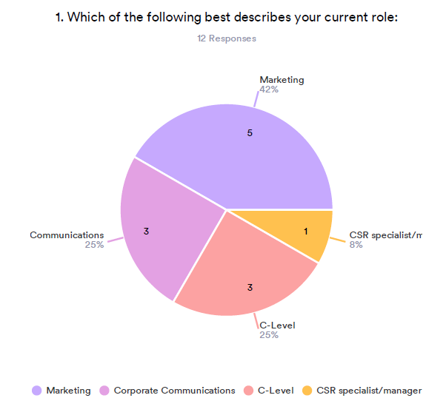
From the displayed graphic, it can be seen that of the observed companies, 42% of the respondents who filled out the questionnaire work in the field of marketing, 25% in the field of communications and C-level, and only 8%, or 1 participant, works in the field of CSR.

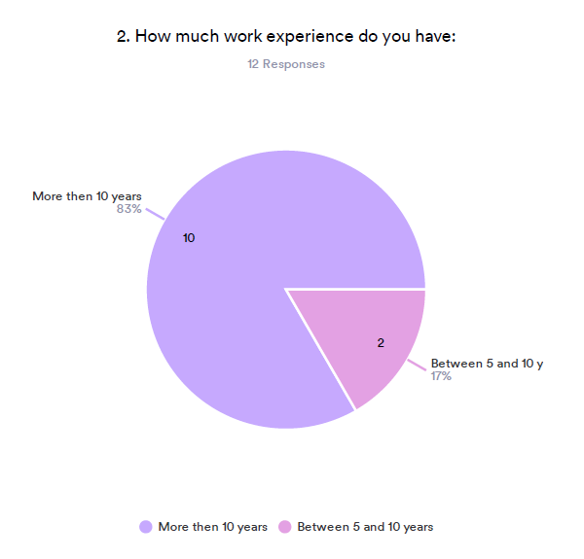
Of the respondents who filled out the questionnaire, 82% of them have more than 10 years of work experience, while 17% of them have between 5 and 10 years of work experience.

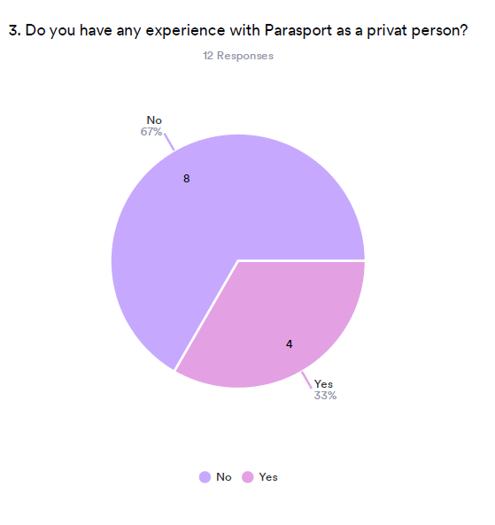
Of the respondents who filled out the questionnaire, 67% of them, i.e. 8 of them, have no experience with Parasport, while 33% of them stated that they have, as private individuals, experience with Parasport.
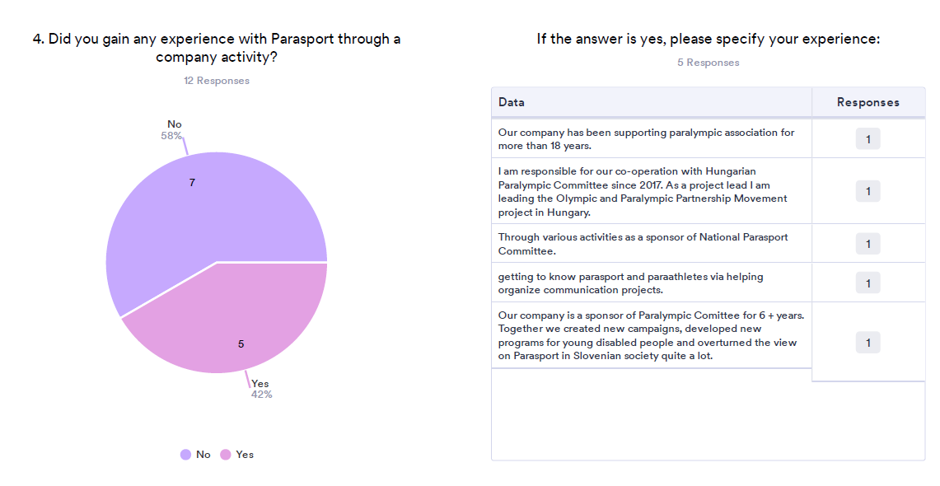

58% of respondents stated that they did not get experience in Parasport through activities in the company where they work, while 42% of them got experience in the company itself. Of those respondents who got their experience in the company, most of them got their experience in Parasport from the company's cooperation with the National Paralympic Committee.

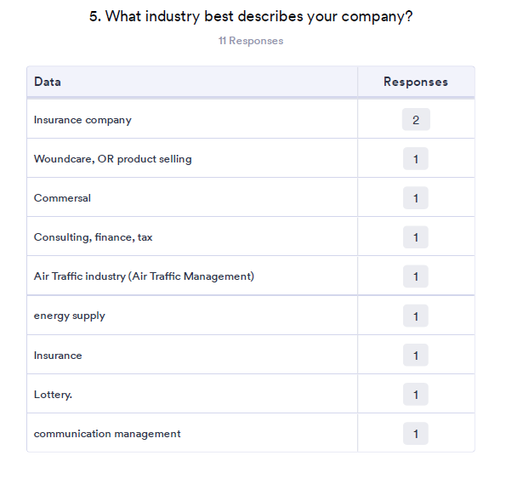

The respondents stated that they work in the following industries: insurance company, wound care, commercial, consulting, finances, air traffic industry, energy supply, insurance, lottery, communication management.
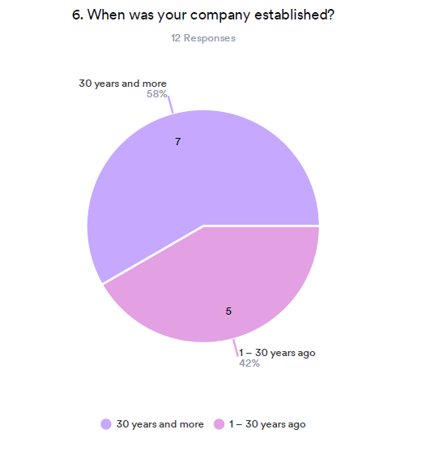
58% of the companies were established more than 30 years ago, 42% between 1-30 years.
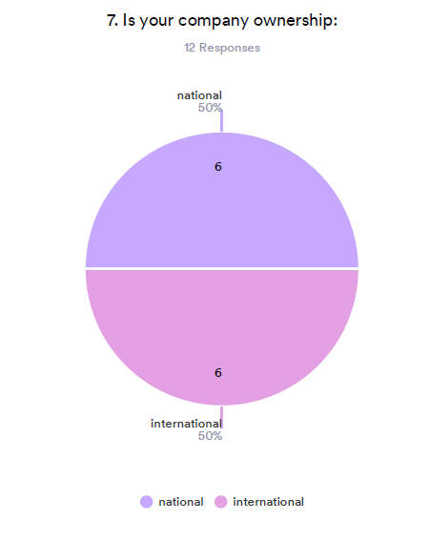
Regarding the ownership of the company, the responses are equal: 50% of the companies are in the national ownership and 50% in the international.
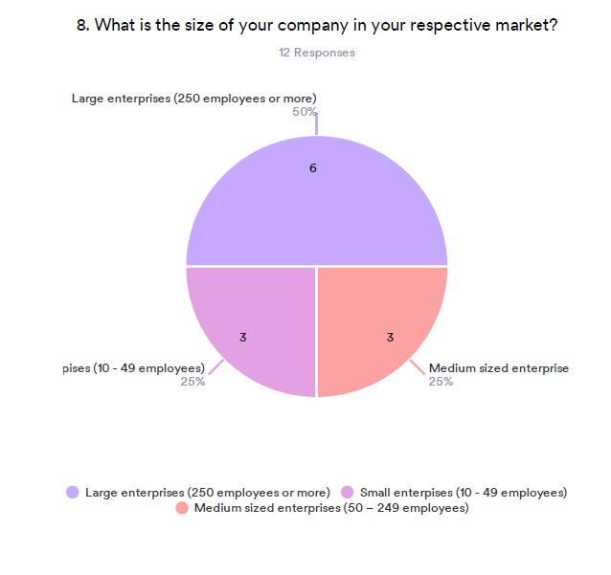

50% of the respondents work in large enterprises, 25% in medium and 25% work in small enterprises.
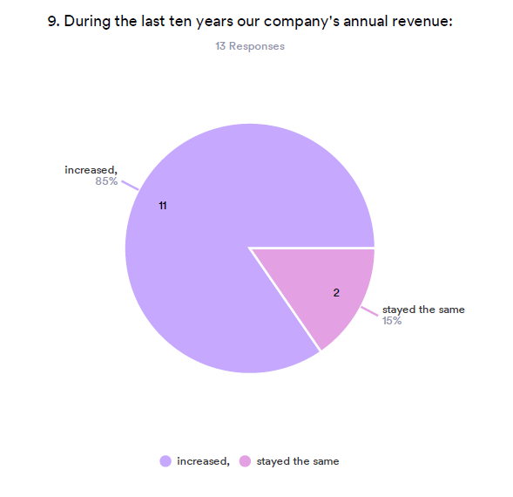
If we talk about companies annual revenue, 85% of the respondents noted that their companies revenue increased, 15% stayed the same.

When we talk about the level of awareness in organizations regarding the terms, we can see the following results:

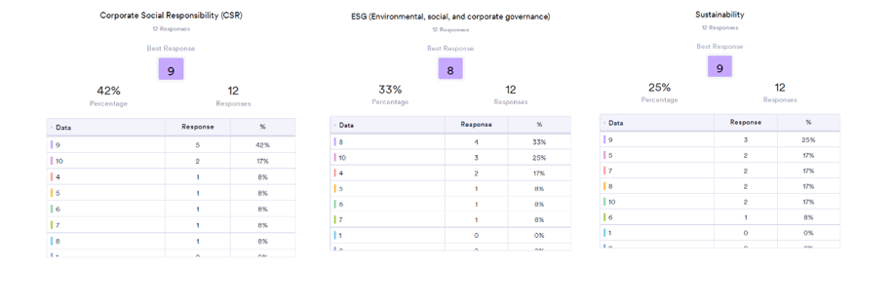
On the scale from 1-10, 42% of the respondents said that the level of awareness regarding the CSR is 9, 17% gave 10, and the other gave 4-8. If we talk about the level of awareness regarding the ESG, 33% gave number 8, 25% gave number 10, 17% gave number 4 and the rest gave numbers from 5-7. And last, and 25% said that the level of awareness regarding sustainability is 9, 17% gave the numbers 5,7,8 and 10 and 8% gave number 6.

If we talk about the importance of the following areas in the company, we can see the following results:
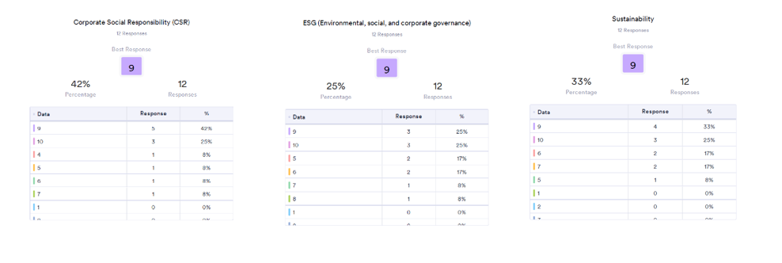
On the scale from 1-10, 42% of the importance of the CSR is 9, 25% gave 10, and the other gave 4-7. If we talk about the importance of the ESG, 25% gave numbers 9 and 10, 17% gave numbers 5 and 6, and the rest gave numbers 7 and 8. And last, and 33% said that the importance of sustainability is 9, 25% gave the number 10, 17% gave the numbers 6 and 7 and 10 and 8% gave number 5.
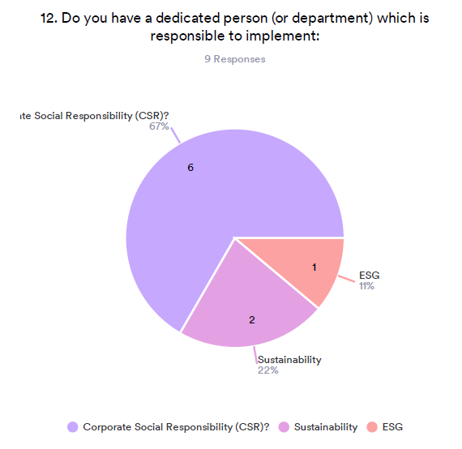

67% respondents noted that they have a person or department responsible to implement CSR, 22% have for Sustainability and 11% have for ESG.

The Next question was dedicated to how well are respondents informed about the rights of persons with disabilities in their country.

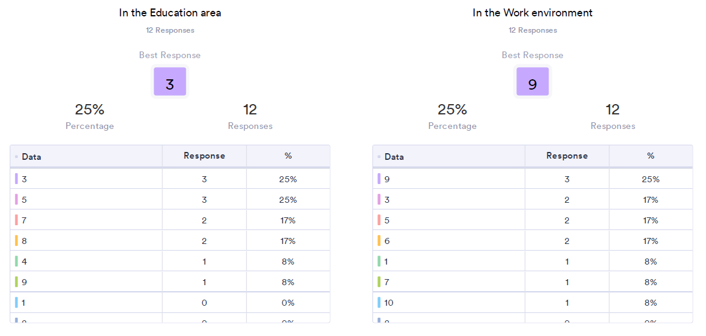
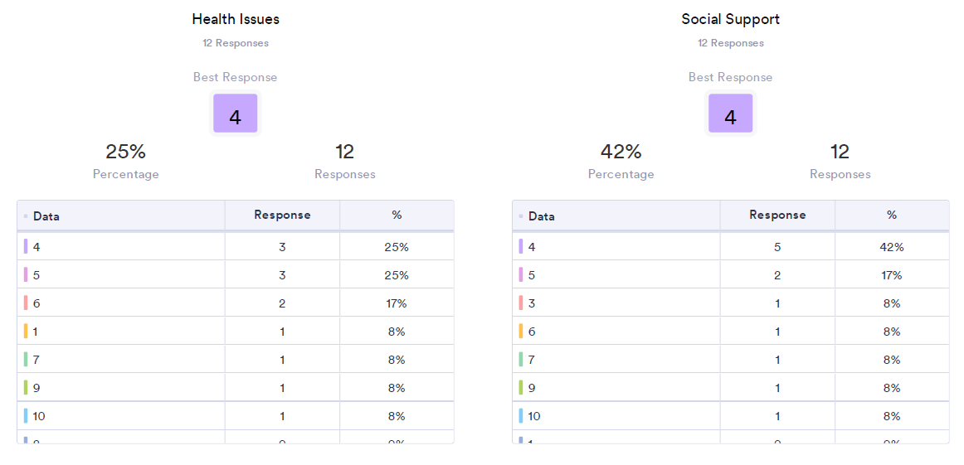
On the scale from 1-10, 25% gave the number 3 and 5 to how well they are informed about rights of persons with disabilities in the education area, 17% gave number 7 and 8, and the other gave 4 and 9. If we talk about the work environment, 25% gave number 9, 17% gave number 3, 5 and 6, and the rest gave numbers 1, 7 and 10. About the health issues, 25% gave numbers 4 and 5, 17% gave the number 6, and 8% gave numbers 1,7,9 and 10. And last, social support, 42% gave number 4, 17% gave number 5, and 8% gave the numbers 3, 6, 7, 9 and 10.

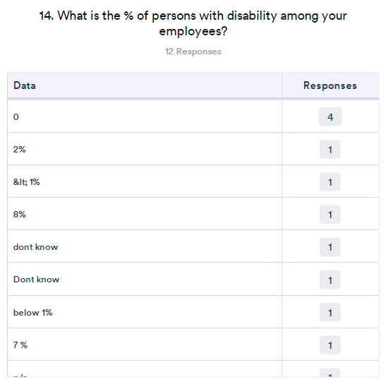

Out of the 12 respondents, 1 respondent said that there are 8% of persons with disabilities among employees, 1 respondent said there are 7%, 1 said 2%, and the rest of the responses were 1%, below 1% or non.
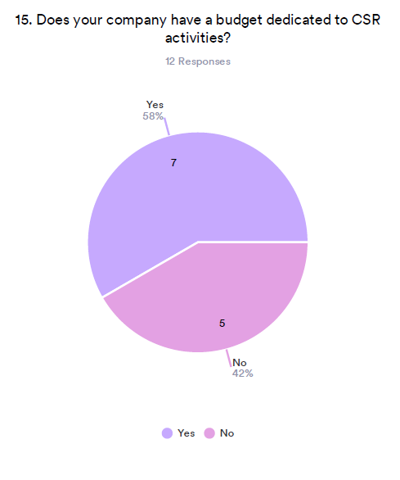
58% of the respondents said that their company has a budget dedicated to CSR opposite of 42% which don’t have a budget dedicated to CSR.
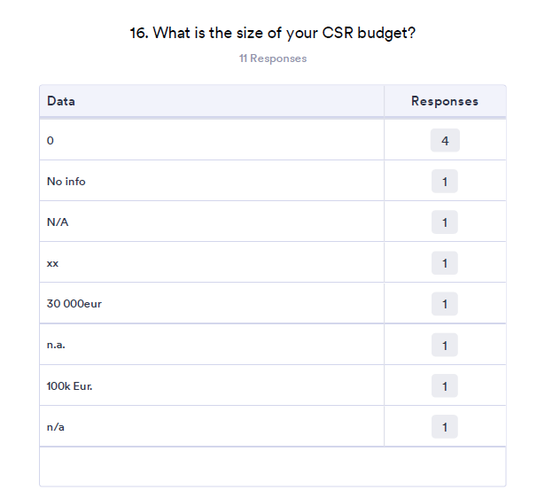
One respondent said that their budget was 100.000 eur and the other said it’s 30.000 eur. The rest of the respondents did not give the information.
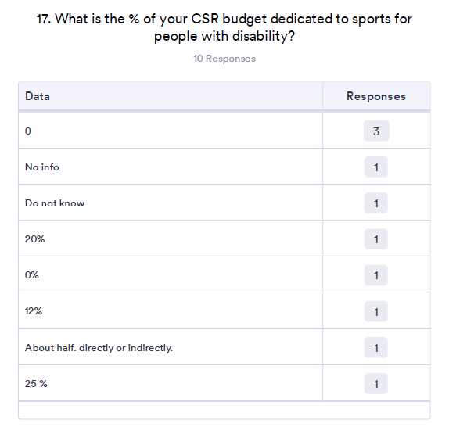
One respondent said that half of the CSR budget is dedicated to sports for people with disabilities, one said 25% is dedicated, two said that 20% and 25% of the budget is dedicated, and the rest said they don’t have any percentage of the budget that is dedicated to Parasport.
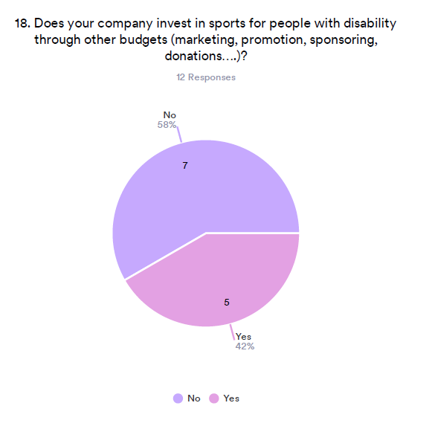
From 12 responses, 58% said that their company does not invest in Parasport, 42% said that their company invest in Parasport.
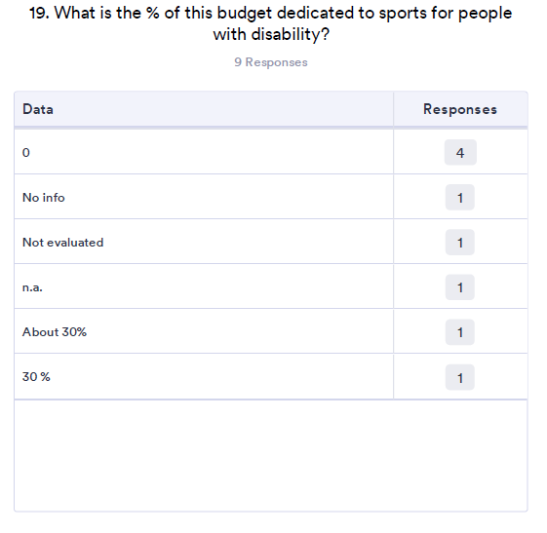
Two of the respondents noted that 30% of their budget is dedicated to sports for people with disabilities.

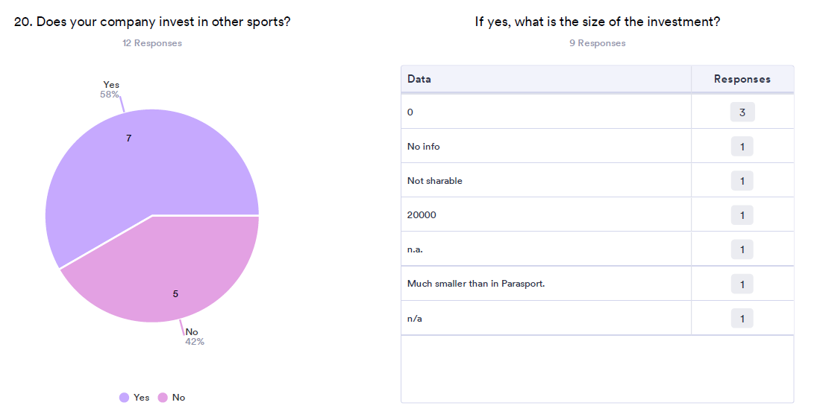

58% of the respondents said that their company invests in regular sport, and mostly in handball, biathlon, tennis, skiing, athletics, basketball, white water canoeing, and the olympic sports in general. The main reason for investment in the sport is marketing objectives.

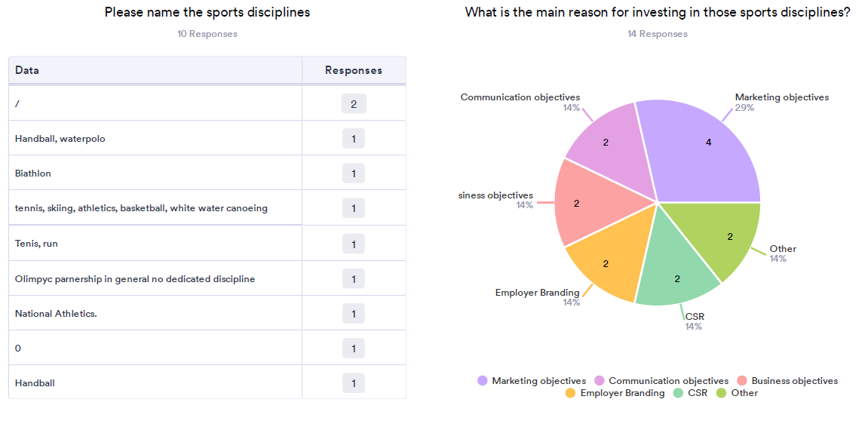

Sport organizations

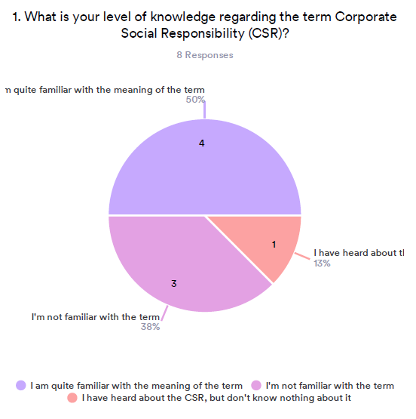

Out of 8 respondents, 50% of them said that they are quite familiar with the meaning of the term CSR, 38% are not familiar with the term and 13% have heard about the term but don’t know anything about it.
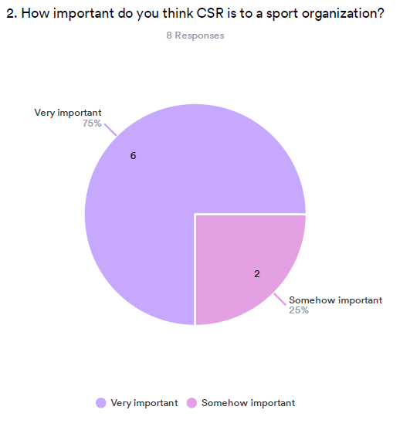

75% of the respondents said that CSR is very important for the sport organization, 25% said that it is somehow important.

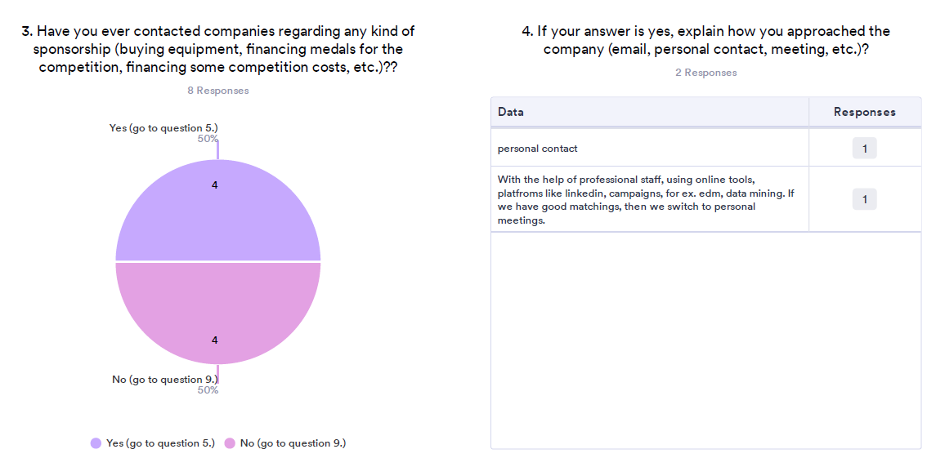
50% of the respondents have contacted companies regarding the sponsorships. The tools for that were personal contact, professional staff, online tools, online platforms, campaigns, etc.
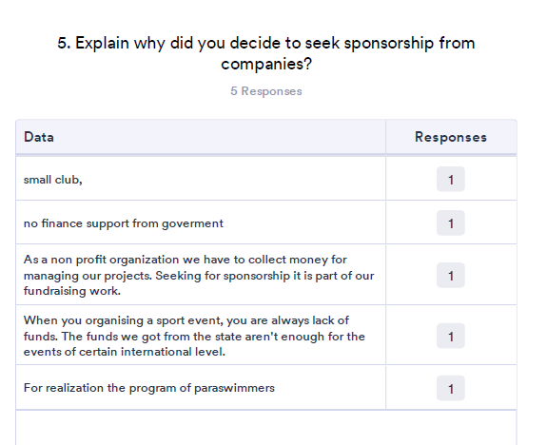

The main reasons for seeking sponsorships were: lack of government support, for managing the projects, financing the sport events, realization of the Parasport programs.
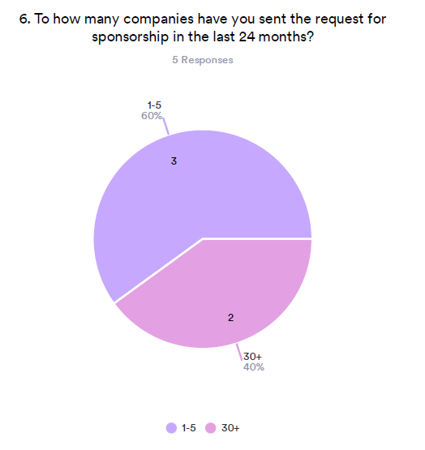
Out of 5 respondents, 60% said that in the last 24 months they have sent 1-5 sponsorship requests, and 40% have sent more than 30 sponsorship requests.
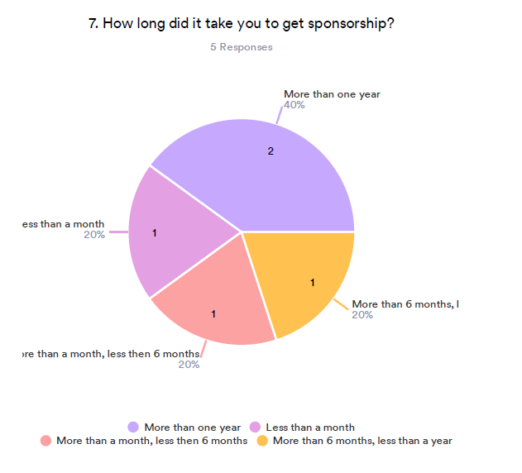

From 5 respondents, 60% of them got the sponsorship in less than a year, and for the other 40% it took more than one year.
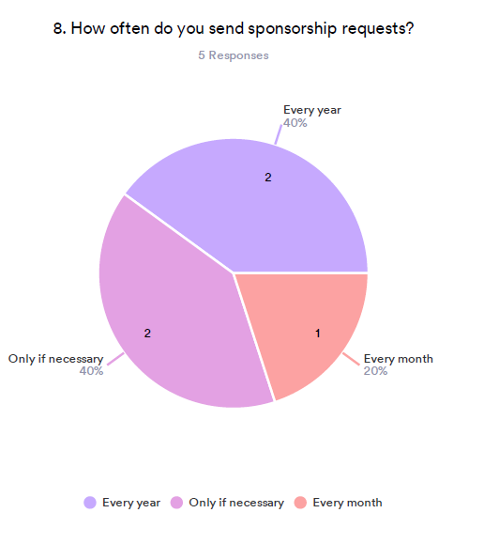
20% of the respondents said that they seek sponsorship every month, 40% seek sponsorship every year and 40% only if necessary.

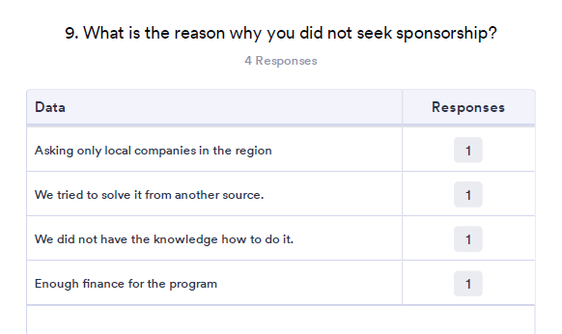

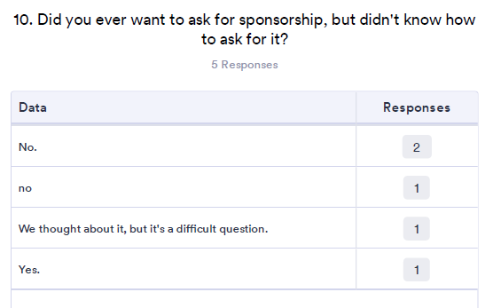

One of the main reasons for not seeking the sponsorship were mostly enough finances for implementation of the program. Only one respondent said that they don’t have knowledge to do so.

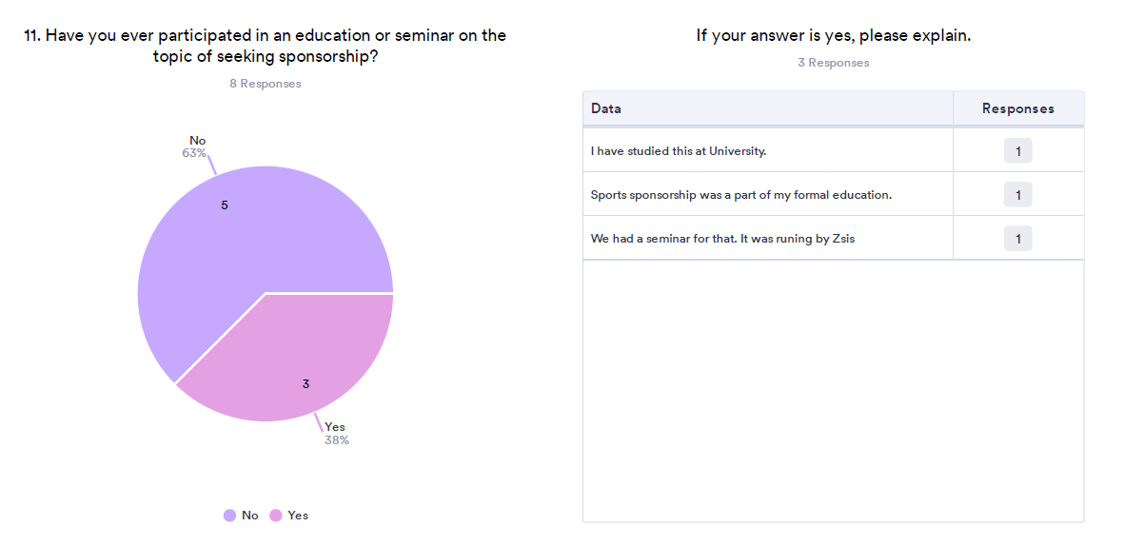
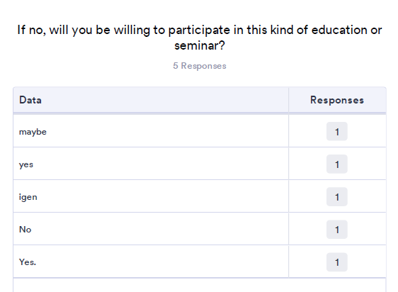
38% of the respondents have participated in an education or seminar on the topic of seeking sponsorship. Most of them have sponsorship as a part of formal education, only one took the seminar. From those who did not participate in such seminar, majority stated that they are willing to participate in seminars regarding sponsorship seeking.

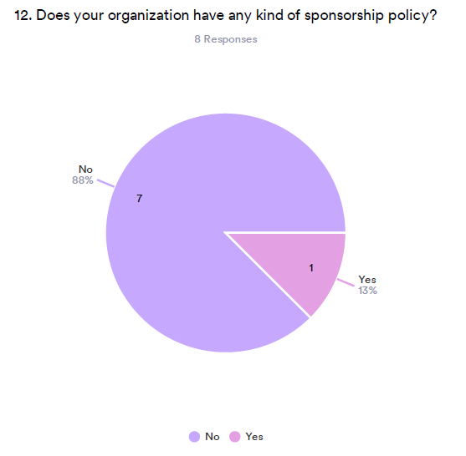
From 8 respondents only one (13%) stated that his sport organization has any kind of sponsorship policy. 88% of the organization don’t have such policy.

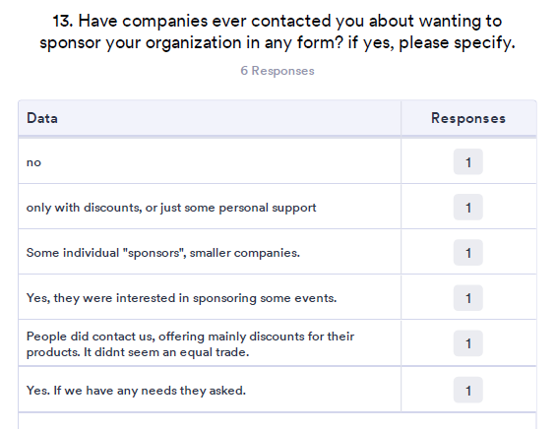

Companies that contacted sports organizations mostly offered discounts on their products. However, some were willing to sponsor some of the sports events or certain individual para-athletes.

Comparison of data by country

The data collected by questionnaires are presented below. The results are divided by country.

Companies

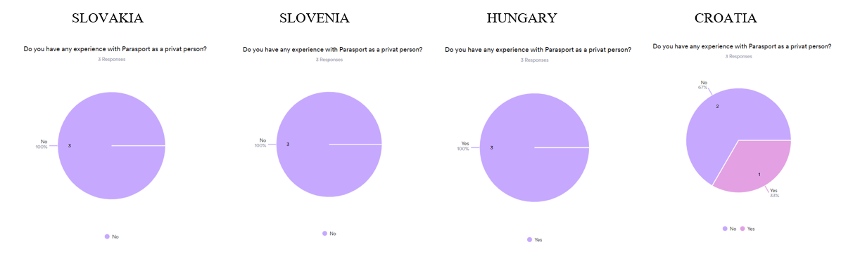
Companies in Slovakia and Slovenia stated that as private individuals they have no experience in Parasport, in Hungary, on the other hand, companies have experience in Parasport, while in Croatia the answers are divided.

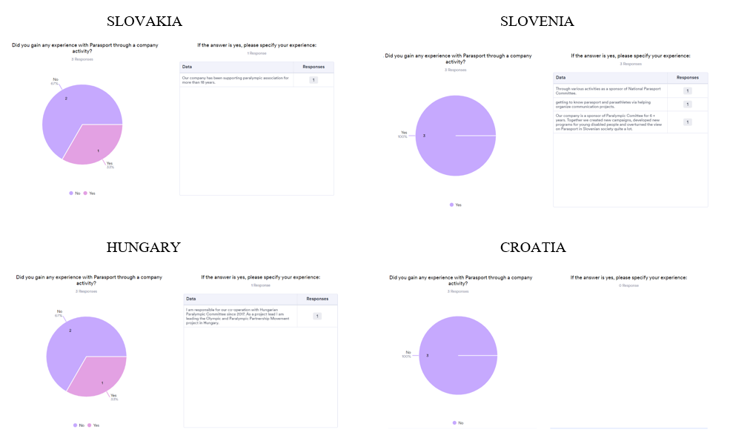
Companies in Slovakia, Slovenia and Hungary introduce employees to Parasport through company activities. In Croatia, companies do not have such activities.

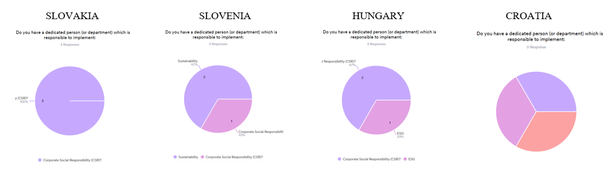

Companies in Slovakia, Slovenia and Hungary have a person or department in charge of CSR, Slovenia also has a sustainability person/department, while Hungary has an ESG person/department.
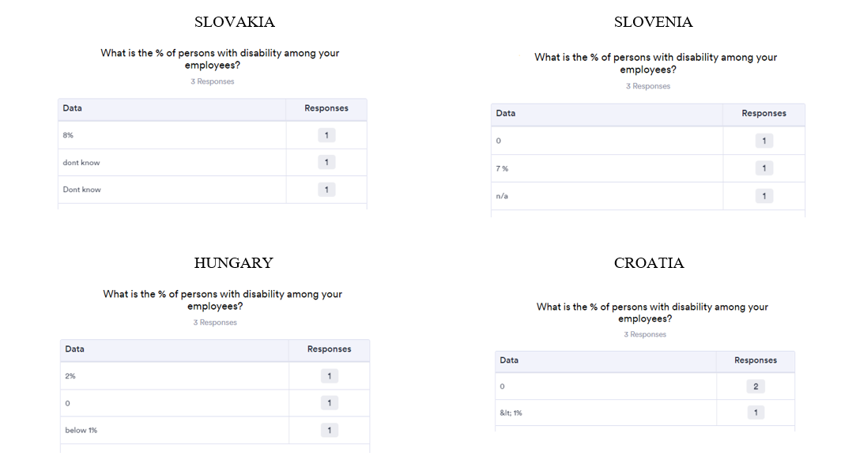

Every participating country has a company that has disabled people among its employees. The highest percentage (8%) is in Slovakia, while the lowest is in Croatia (1%).

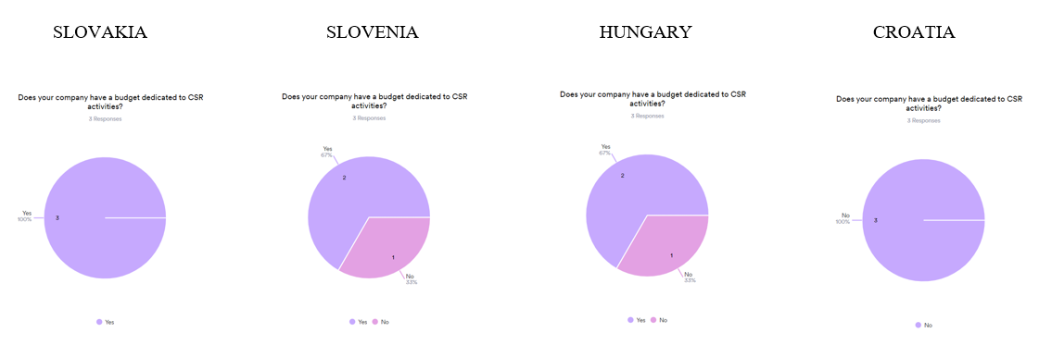
Companies in Slovakia, Slovenia and Hungary have a budget allocated for CSR activities. Croatian companies do not have a specific budget for CSR activities.
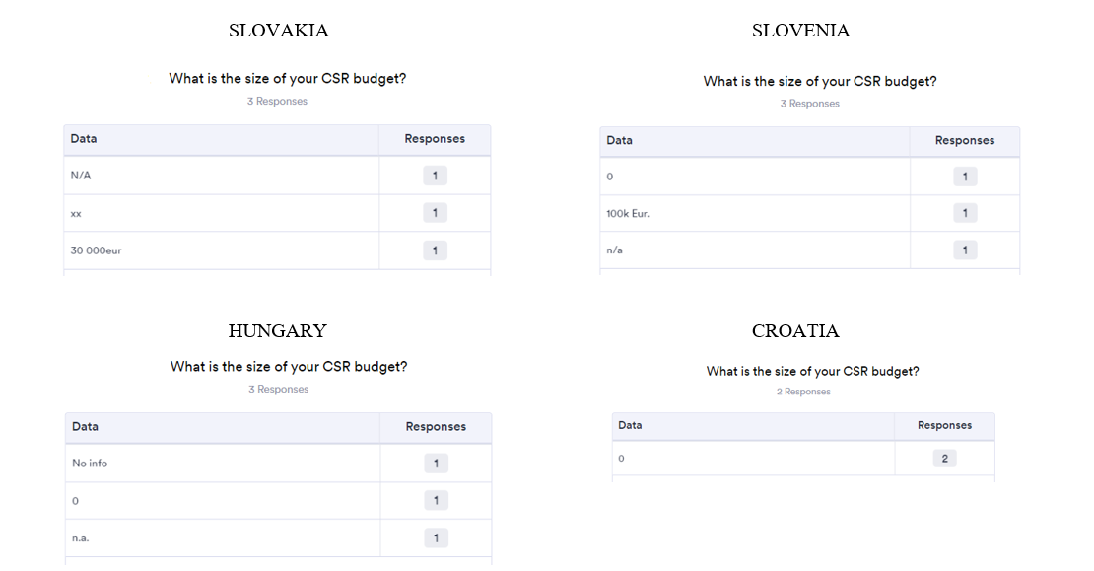

The company in Slovenia has the largest budget for CSR activities, i.e. 100,000 euros, followed by 30,000 euros in Slovakia, while there is no accurate data for Hungary.

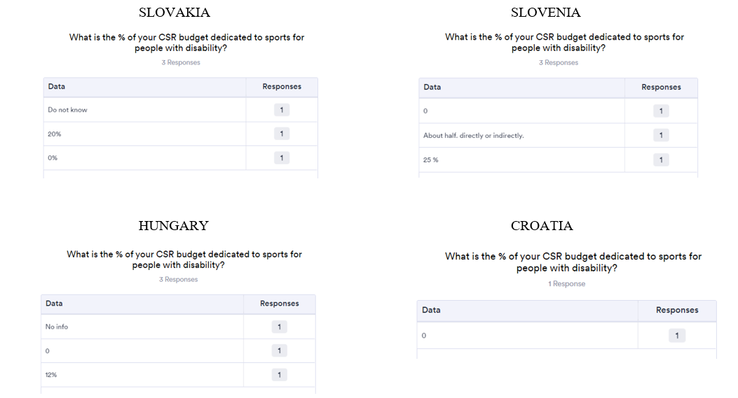
The highest percentage of the CSR budget allocated to Parasport is in Slovenia, where in some companies it reaches 50% of funds, then in Slovakia, where 2% of funds are allocated to Parasport, and finally Hungary, which allocates 12% of funds to Parasport.

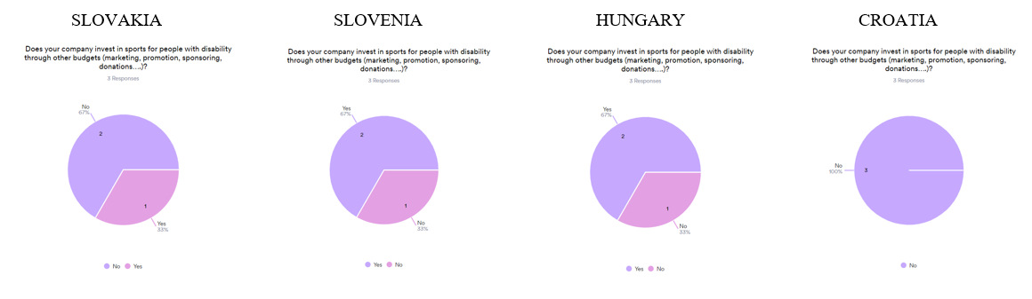
More than 50% of surveyed companies in Slovenia and Hungary finance Parasport from some other sources, 33% of companies from Slovakia. In Croatia, companies do not have a budget from which Parasport is financed.

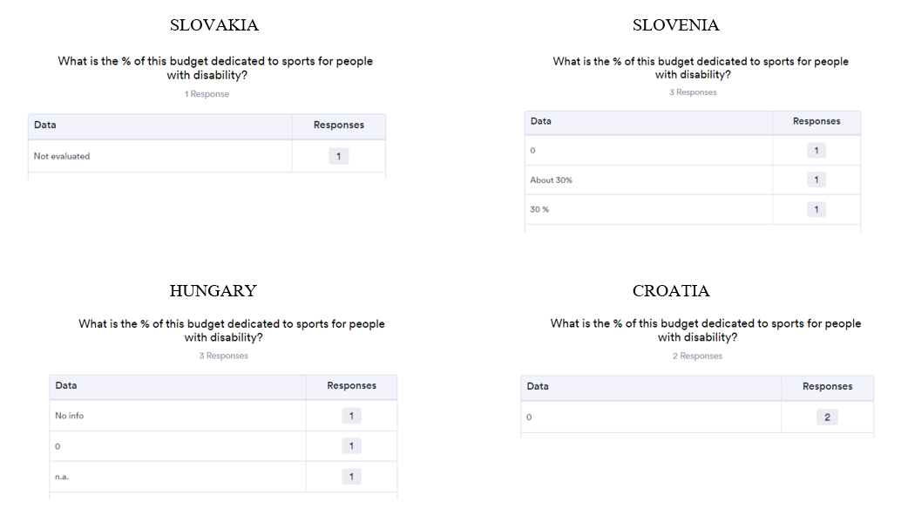
Only companies in Slovenia stated that approximately 30% of the budget is intended for financing Parasport.

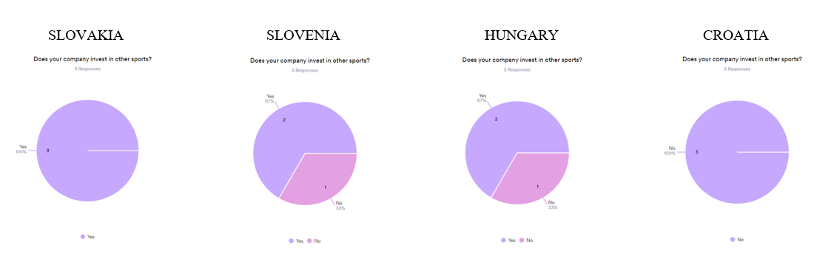

In Slovakia, all surveyed companies invest in regular sports, in Slovenia and Hungary 67% of surveyed companies invest in regular sports, while none of the surveyed companies in Croatia invests in regular sports.

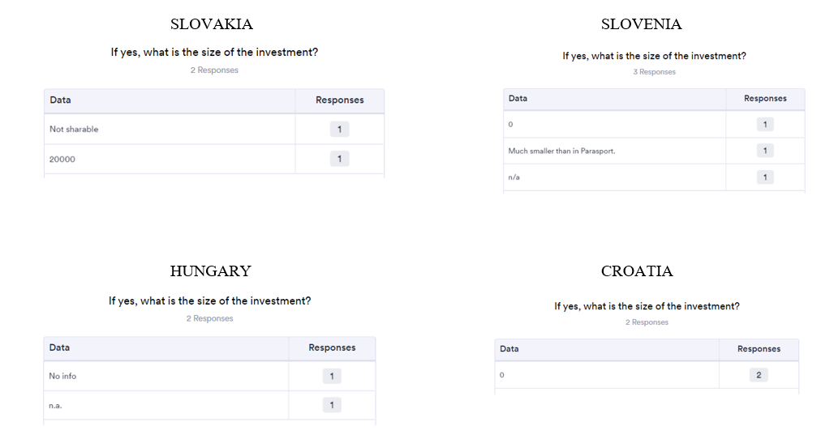
The budget for regular sports in Slovakia is 20,000 euros, while in Slovenia the amount is not specified, however it is stated that a significantly smaller amount is invested in regular sports than in Parasport.

Sport organizations

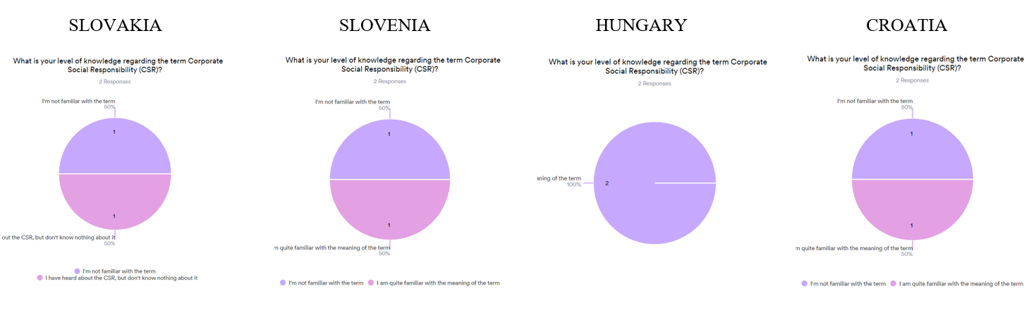
In all participating countries, sports organizations stated that they believe that CSR is important for the organization.

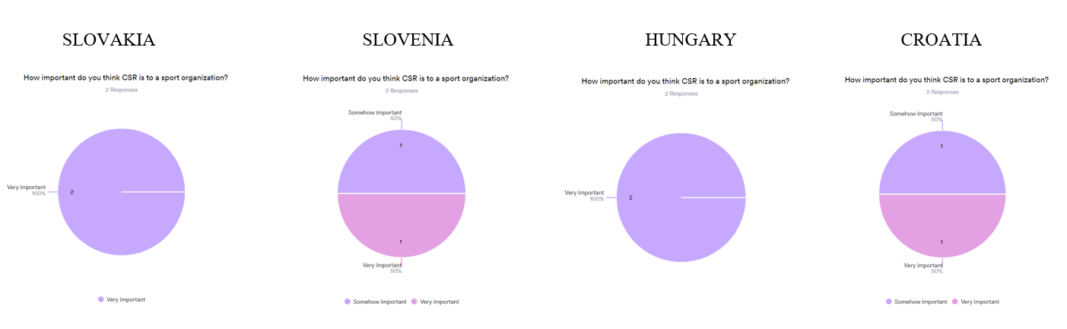

In all participating countries, sports organizations stated that they believe that CSR is important for the organization.

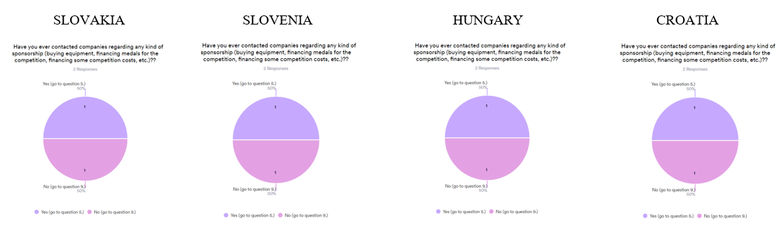

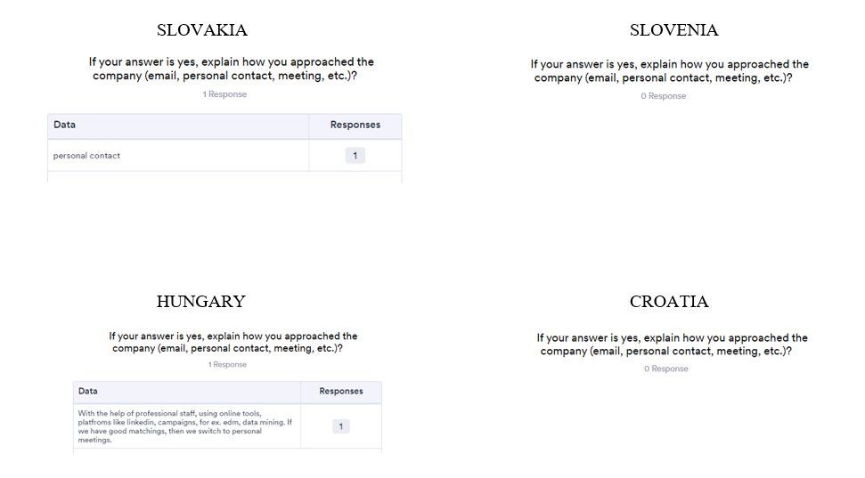
In each participating country, some of the sports organizations contacted the organizations regarding sponsorship requests. The sports organizations of Slovakia made their contact personally, while the sports organizations of Hungary used various ways to establish contact (professional contact, online tools, online platforms, campaigns, etc).

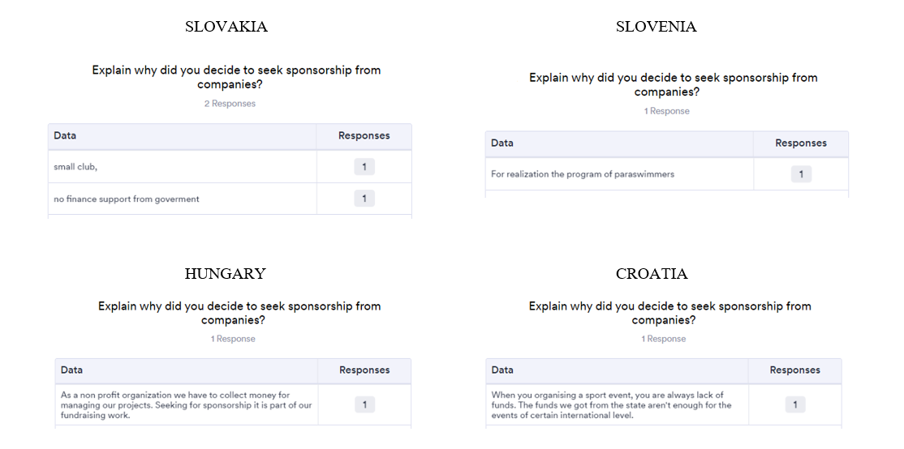

The needs for sponsorships in all countries are mostly the same, insufficient funds from public sources. Therefore, sports organizations have to look for funds from other sources to finance their programs.

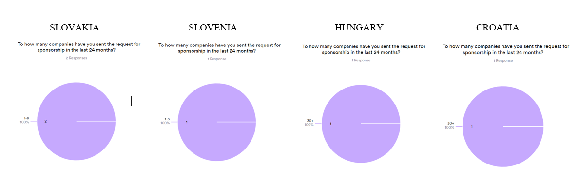
In the past two years, Slovakia and Slovenia sent requests for sponsorships to 1-5 companies, while Hungary and Croatia sent their requests to more than 30 companies.

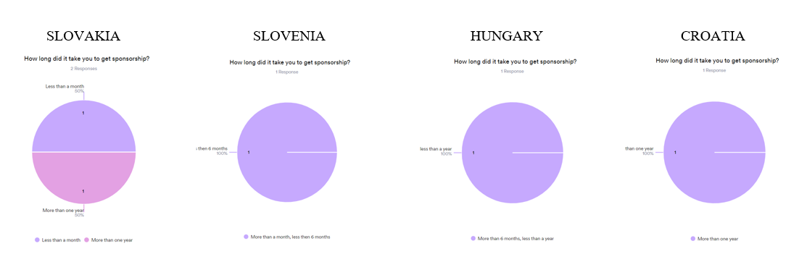
In Slovakia, it took either a month or more than a year to get a sponsorship. In Slovenia and Hungary it took less than a year to get sponsorship, while in Croatia it took more than a year to get sponsorship.

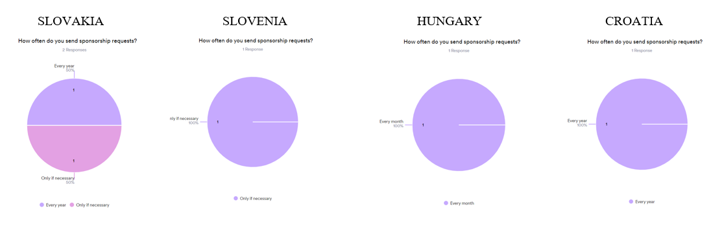
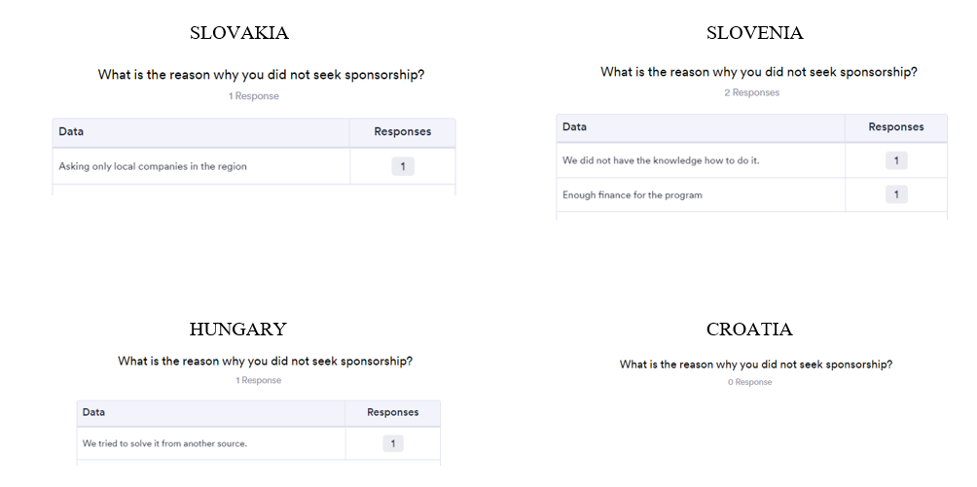
Sports organizations of all countries send sponsorship requests on a regular basis. The reasons are mainly the lack of funds to finance activities. However, the reasons for not seeking sponsorship are mainly financing from other sources of funds. The need for education on the topic of seeking sponsorship was expressed only in Slovenia.

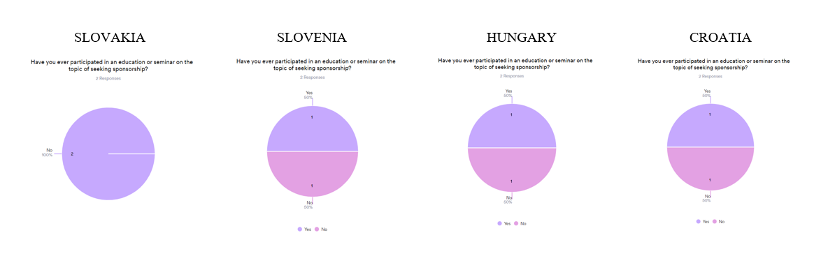

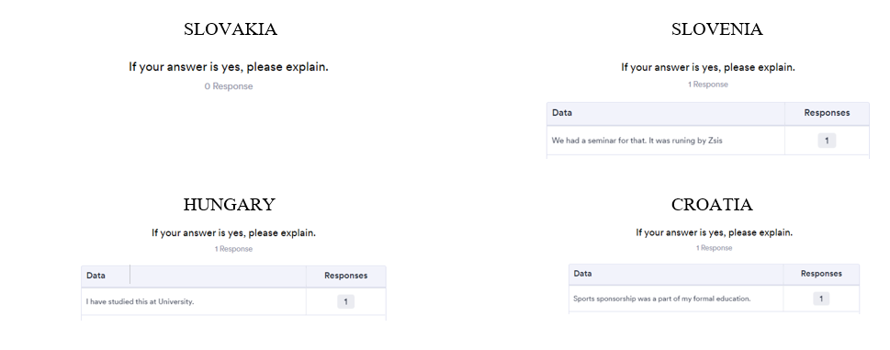

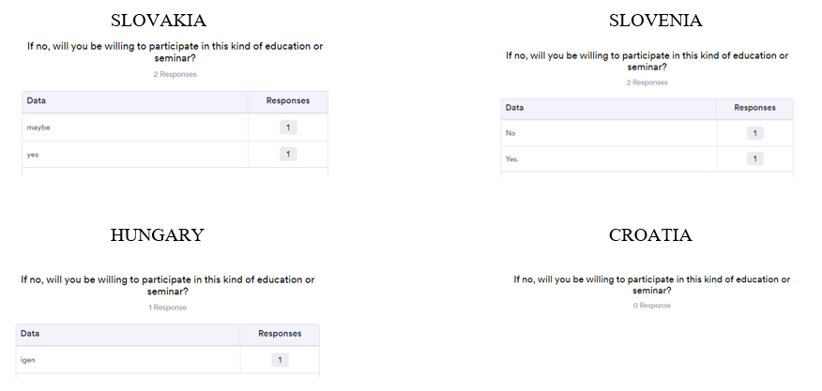
Sports organizations of all participating countries except Slovakia participated in some kind of seminar or education on the subject of sponsorship. Also, organizations are generally willing to participate in this type of education.

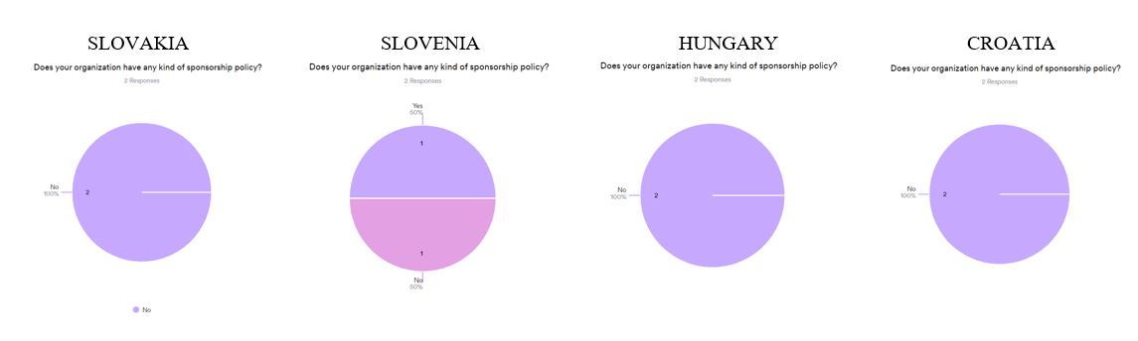

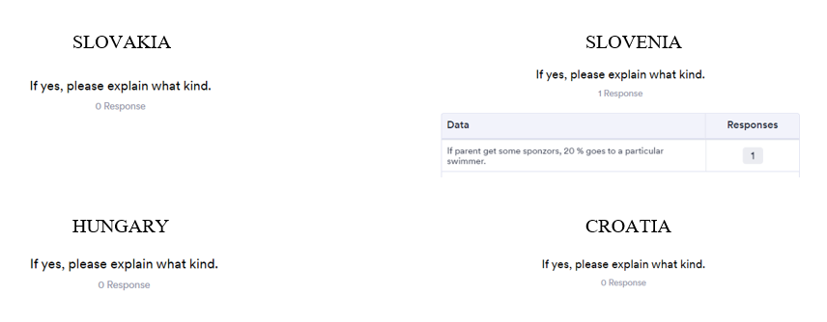

Only in Slovenia there is a kind of sponsorship policy. If the parents get some sponsors, 20% goes to individual swimmer.

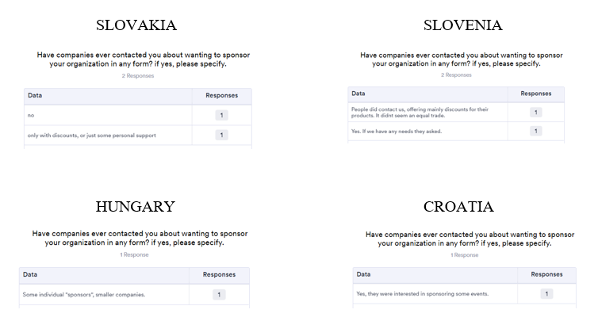
In each participating country, sports organizations were contacted by companies with the intention of some kind of sponsorship.

Interviews

The interviews were conducted with the aim of further clarifying the data obtained from the questionnaire.

Target group and list of questions asked

Interviews were conducted with 12 companies and 8 sports organizations from four participating countries that expressed their desire to be interviewed in the questionnaires.

Questions for companies

- Information on how a company respects the rights of persons with disabilities in its company policies.
- Information on accessibility for people with disabilities related to the physical environment and other services.
- Please provide information on the support measures (services or financial) your company takes for people with disabilities.
- What does your company do regarding measures for diversity, equality, and inclusion for people with disabilities?
- What is the main reason why you/your company is not familiar with Parasport?
- Would you be willing to learn more about Parasport?
- What would need to happen for you or your company to consider investing in parasports?

Questions for sport organizations

- What is your level of knowledge regarding CSR?
- Have you ever contacted any company regarding CSR?
- Have you ever seek for sponsorship?
- What was the reason for the initial sponsorship request?
- How important is sponsorship for your sports organizations?
- How likely is it that your sports organization will further seek sponsorship? Why?
- What is the reason that you have not to seek for sponsorship?
- Have you ever participated in any seminar regarding the topic of seeking sponsorship?
- If not, why not, if there will be an opportunity for participation will you be willing to participate, etc?
- What would you say that makes you think that there is no interest in parasport?

The most important notes from the interview

Each participating country conducted interviews with three companies and two sport organizations that expressed their desire to be interviewed in the questionnaires. The questions asked in the interviews are based on supplementing and deepening the answers given in the questionnaires. Below are the main conclusions of the conducted interviews by country.

Slovakia

Company policy:
The company has a comprehensive disability inclusion policy that ensures the rights of persons with disabilities are considered in their policies.
Accessibility for persons with disabilities is a priority, including physical environment modifications, alternative document formats, and flexible working hours.
The company takes actions to support persons with disabilities, offering workplace accommodations, training, and collaborating with external support organizations.
DEI measures are implemented to promote inclusivity, including policies, guidelines, and accommodations for individuals with disabilities.

Questionnaire Responses:
The respondents have extensive knowledge about Parasport and can provide detailed information on various aspects of it.
Companies actively participate in supporting Parasport through sponsorship and organizing local events.
The initial investment into Parasport was driven by a belief in the power of sports to inspire and empower individuals with disabilities.
Companies consider investing in Parasport highly important (rated 9 out of 10), aligning with their brand values and the desire to make a positive impact.
It is highly likely that the company will further invest in Parasport due to the positive outcomes witnessed and the belief in its transformative potential.
Employee awareness of the Parasport investment varies, with some employees having a good understanding while others may have limited knowledge.
The company has noticed significant positive changes since the Parasport investment, including increased employee morale, engagement, teamwork, productivity, and a greater sense of purpose.

Slovenia

Companies:
Most of the big companies, especially global ones, consistently follow Slovenian legislation in enforcing the rights of employees, and they pay particular attention to the principle of equality and justice. They are trying to adapt the employees' workplaces and work in accordance with their limitations. Some companies have special rules/policies for persons with disabilities, but this is not common in Slovenia yet.
Furthermore, regarding the accessibility for persons with disabilities:
- office/building: administrative buildings are mostly accessible for people with disabilities (elevator), wheelchairs, most of big companies also have toilets for the disabled in headquarters.
- documentation: Lots of companies follow the paperless principle, so that all documents are accessible in digital form and as such are suitable for possible use with devices for greater accessibility (readers, etc.)
- flexible working hours: Most of companies provide their employees flexible working day, which allows them to adjust their obligations at work to their personal obligations
- other (specify): Home office - employees in the administration are allowed to work from home up to 5 days a week by agreement with the manager; due to the nature of the work, this cannot be offered to employees in stores and warehouses.

Since 2016, one of the companies (Lidl) have been supporters/sponsors of the Association for Sport of Disabled People of Slovenia - the Slovenian Paralympic Committee. They also support other projects for people with special needs - Pomežik suncu (collection of funds for vacations for children with special needs), support of events intended for children with special needs (Mini Obstacle Race at URI Soča, Igraj se z mano - Center Janez Levac), etc. They have also adapted one cash register in all stores with a special handle for the card payment device so that it is particularly flexible and useful for people in wheelchairs.
Regarding the DEI measures and people with disabilities, in big companies they create an inspiring, inquisitive and empowering culture based on integrity and the creation of a diverse, safe and inclusive work environment in which everyone can be who they are. Within the framework of the Diversity, Equity and Inclusion initiative, four groups operate: Disabled Persons, LGBTQI+ Community, Intergenerational Cooperation and Diverse Talents. In smaller companies DEI is not implemented to that extent.
When we talk about the knowledge of Parasport, especially sponsors of NPC Slovenia are strongly involved in the activities of the NPC and parasport and they know the main peculiarities of parasports. Most of the interviewed companies are sponsors of NPC Slovenija, so they are strongly involved in supporting Parasport in Slovenia.
Through sponsorship companies enter the world of people with disabilities, because together we can create an inclusive society, raise awareness among the general public about the importance of including people with disabilities, enable young people with disabilities to participate in sports activities, and build an inclusive internal company culture in which everyone should feel valued and accepted .
Companies were looking for an interesting sports sponsorship, which not many companies in Slovenia had undertaken until then. Due to shared values and wishes, they were able to formulate common long-term goals of sponsorship cooperation with the aim of creating greater recognition of para-sports and para-athletes in Slovenia.
WheSince interviewed companies made parasport sponsorship as one of their strategic projects, they will continue our cooperation in the future. The results brought about by the cooperation show that they are on the right track to create good recognition of para-sports in Slovenia and offer para-athletes the support they deserve.
In internal channels, they regularly inform their employees about the achievements of para-athletes, they also present them in their internal magazines, and during special events (championships, Paralympic Games) we also publish fan content with the aim of raising the visibility of the company's sponsorship investment.
Companies said that the employees themselves tell us that they are extremely proud that we have undertaken as a company, and the project is also mentioned to us as a recognizable reference by potential candidates during job interviews.

Sport organizations
When we talk about the sport organizations knowledge of CSR, it is quite a different experience. Some organizations have a lot of knowledge (especially if they have very close experience with the company/organization which is very CSR active (for example with some global companies).
Some sport organizations have contacted companies regarding the CSR, especially bigger ones. Some of them, particularly smaller sport organizations, don't have these kinds of experiences.
Most of sport organizations have seed for sponsorships, even smaller sport organizations especially by organizing bigger sport events. Bigger sport organizations regularly seek sponsorships. The financing from national funds of sports and public financing is not sufficient, so organizations need to seek for other finance sources.
When we talk about the importance of sponsorship for a sports organization, it depends on how strong is public and fund financing. If this is not sufficient for the operation of the organization, it is important to get some sponsors. If organizations also need more activities for their participants, they usually have contracts with sponsors.
The same is with the willingness to seek sponsorship, it again depends on the other sources of financing. Some organization have also a problem that need to wait for the public money and don't have enough own finance sources – that why need sponsors to get some money for their regular activities and sport programs.
In the past some of the clubs/organizations were self sufficient and as they only offered recreation for adults, there was not much interest from organizations for sponsorship.
Regarding the seminars with the topic of sponsorship, most of the bigger organizations participated in these kinds of seminars, but not the smaller ones. They get information from different sources – most of them from local enterprising organizations.
The one who did not participate in such a seminar, if there is an opportunity to participate, they are all willing to do so. Especially for growing clubs and organizations it is more than welcome. They are looking for additional funds for supporting the young and the competitors as well as expanding their offer to the general public.

Hungary

Companies:
Generally, the contribution towards the Parasport and Parasport sector’s development from companies has been very minimalist over the years, more companies need to come forward to contribute and support the sports. However, the encouragement of carrying out sporting activities under corporate social responsibility continues to grow and large companies in Hungary are setting examples of great investments in sports.

A large company:
The Allianz is one of the worldwide sponsors of the international Paralympic Movement since 2006, and the Allianz Hungary has been supporting the Hungarian Paralympic Committee since 2012. Since 2021 they have sponsored 2 Para athletes. This is the reason that the inclusion is very important to the company, as they treat everyone equally regardless of physical disability.
The company has a fully accessible headquarter and they provide flexible working hours for people living with disabilities, further the company has an accessible website and customer service.
They constantly follow the main Parasport events through the Paralympic Committee and news about Parasport events and Para athletes through the various media.
Supporting different forms of sport is very important to this company. Inclusivity is a priority for their brand. The company will continue to support Parasport in Hungary based on international cooperation until 2028 which provides the basis and direction for this.
They constantly inform their colleagues about various international activities and organize local activities with the participation of Para athletes. The example of Para athletes provides motivation for employees.

Smaller companies:
The companies’ regulations and policies take full account of the rights of people with disabilities. They have accessible offices and provide them flexible working hours’ possibility.
The company sensitizes both internally and externally, and helps the acceptance of people with disabilities both inside and outside the company. Employees come to the company from many places. Both companies know the results of Parasport well, and the Parasport events.
One of the companies has a possibility to support the Parasport movement by supporting integrated and inclusive events. Most of their customers struggle with some kind of disability, so this is where the motivation comes from. The company is planning the support in the future due to the company's health-conscious plans. Colleagues of the company are becoming more informed, paying more and more attention to the Parasport, including people with disabilities. The other company doesn’t have the possibility for the support due to a tiny budget.
Sport organizations:
Evaluating the interviews with the representatives of the two sport organizations, it can be stated that sponsorship is a very important field both in the able-bodied sports and in Parasport.
The phenomenon of CSR activity is well-known for both associations in question, but continuous development and expansion of knowledge in this area is also indispensable.
It is one of the main goals for both sport organizations to obtain as many sponsorships as possible for as many Para athletes as possible. Fortunately, both sports organizations have Para athletes who benefit individual sponsorship from a small or large company. Sponsors best help the Para athletes in going to training and competitions, but they also emphasize helping them lead a healthy and vital lifestyle.
On the other hand, finding a sponsor is often a big challenge in the sport of the able-bodied, but when it comes to Parasport it is even more challenging, as it is difficult to find sponsors. No matter how much they try to involve external sources, based on practice and experience so far, this can only be done to a small extent and to a limited extent.

Croatia

Organizations:
First company does not have specific policies or measures in place to respect the rights of persons with disabilities at the moment because, similarly as the first interviewee mentioned, they don't have employers with such needs. The physical environment, including the office and building, is not adapted for accessibility. Documentation and flexible working hours also do not cater to persons with disabilities. The company stated that if an individual with a disability met the required qualifications and could perform the job, they would consider accommodations depending on the degree of disability and the possibility of modifying office space.
Regarding support for persons with disabilities, the company does not have any measures in place due to the absence of employees with disabilities. However, they do make annual financial donations to associations for children with special needs.
In terms of diversity, equality, and inclusion, the company has not encountered a need to include persons with disabilities. They focus on achieving diversity between genders but have not had experiences with persons with disabilities.
The company has limited knowledge and involvement in parasports. They do not participate in supporting para sports or sponsor sports workshops. The main reason for this lack of involvement is the absence of opportunities or invitations and a focus on programs for donating to children with special needs. The company expressed a willingness to learn more about parasports and would consider investing if they were made aware of the opportunities through an introductory email, presentation meeting, or invitation.
In conclusion, the company does not currently have policies or measures specifically catering to persons with disabilities. Their involvement in parasports and sports-related activities is limited, primarily focusing on financial donations to associations for children with special needs. However, they expressed openness to learning more about parasports and potentially investing in it if presented with the opportunity.
Second company currently does not have previous experience employing people with disabilities but emphasizes its commitment to equality and fairness. Their company policies strongly promote non-discrimination based on disability, and they comply with relevant laws and regulations. They are open to adapting workspaces for accessibility if individuals with disabilities meet the job requirements.
Regarding accessibility in the physical environment and other services, the company does not have specific support measures in place tailored to people with disabilities. However, they express a willingness to explore and implement such measures based on the needs and capabilities of the company. They highlight the importance of providing adapted working conditions, accessibility in the workplace, and support for education and skill development. While they currently lack specifically adapted documentation, they acknowledge the significance of information accessibility and are considering options for adaptations if they have employees with disabilities in the future.
The company currently does not have specific support measures or measures for diversity, equality, and inclusion for people with disabilities since they don't have any employees with such needs. However, they recognize the importance of these topics and express openness to collaborating with organizations and initiatives that support diversity and equality for people with disabilities. They also consider the possibility of establishing support programs and participating in disability awareness training programs.
The main reason why the company is not familiar with Parasport is their lack of previous experience or involvement in those activities. Their expertise and interests primarily lie in tax, accounting, finance, and law. However, they express a desire to expand their knowledge and understanding of Parasport and explore ways to provide support and contribute to its development in the future.
The company confirms its willingness to learn more about Parasport and highlights the potential benefits of collaboration between its organization and Parasport. They express a desire to gather information, participate in discussions, and consider possibilities for collaboration and support.
Regarding investment in Parasport, the company would need to thoroughly explore the opportunities, benefits, and resources they can provide. This would involve understanding their financial capability, potential benefits for their company, and sustainable ways to support Parasport. They are open to discussing and negotiating possibilities such as annual or one-time sponsorships of competitions, sports preparation, or support for specific athletes. They acknowledge the importance of inclusion and support for people with disabilities and are willing to improve their company's policies and practices in this regard.
Third company mentioned that it does not currently have specific accessibility measures in place but expressed a willingness to establish them through collaboration with relevant organizations or the implementation of legal regulations. They also highlighted the strict selection criteria for their core business, making it challenging for individuals with disabilities to enter certain roles.
Regarding support for individuals with disabilities, the company mentioned that it has made donations to programs upon request and has supported initiatives organized by the company's employees or the labor union. The company's knowledge and involvement varied among employees, depending on their personal interests and experiences. The company has provided financial support for para-sports events and programs, and they expressed a strong belief in the importance of such investments for both connecting with para-athletes and contributing to the local community.
Regarding the importance of investing in para-sports, the company rated it as highly significant 9-10/10), emphasizing the need for continuous support and collaboration. They expressed a high likelihood of the company continuing to invest in para sports in the future. However, they mentioned that employees' knowledge about para-sports and company investments primarily comes from external sources, and there is room for improvement in internal communication and awareness.
In conclusion, the company highlighted the importance of strengthening the collaboration between para-athletes and the company. They emphasized the need for initial contact, explaining how the para-sports world operates, and establishing opportunities for collaboration. They expressed a desire for the company to take the first step in building this relationship.

Sport organizations:
During the interview, the first sports organization discusses its familiarity with corporate social responsibility (CSR) and its limited practical experience with it in the sport. They mention gaining knowledge about CSR through studies at university and various sources. They explain that they have contacted companies for specific requests but have not received positive responses from a large percentage. They express challenges in seeking sponsorships due to the small market size and limited interest in parasport. The structure of the organization and its affiliation with the National Paralympic Committee (NPC) restricts its ability to form partnerships and use certain terms and branding. Despite these limitations, they emphasize the importance of seeking sponsorships and acknowledge the need for realistic expectations. Small sponsorships primarily cover the organization of competitions, including compensating individuals involved, while equipment and clothing are not a significant requirement.

The interview with the second sport organization discusses sponsorship and corporate social responsibility (CSR) in the context of a sports organization. The interviewee mentions that they are not familiar with CSR concepts and have not contacted any CSR companies. They rely on the Croatian Paralympic Committee for funding and have not actively pursued sponsorships. They previously attempted to secure European funding for a project to improve table tennis clubs' conditions, but it did not materialize. The interviewee expresses interest in future European projects and believes that EU funds have greater benefits for development compared to sponsorship funds. They mention a focus on personal sponsorships for individual players rather than seeking sponsorships for the entire organization. Lack of media coverage is identified as a reason for limited interest in parasport.

Comparison of data by country

Comparing the results of the research obtained through interviews, we draw the following conclusions:

Slovakia
Companies have a comprehensive disability inclusion policy that ensures the rights of persons with disabilities are considered in their policies, accessibility for persons with disabilities is a priority, including physical environment modifications, alternative document formats, and flexible working hours, companies takes actions to support persons with disabilities with accommodations, training, and collaboration with external support organizations and last but not least promotion of inclusivity. The respondents have extensive knowledge about Parasport and can provide detailed information on various aspects of it. Companies actively participate in supporting Parasport through sponsorship and organizing local events, they consider investing in Parasport highly important due to the positive outcomes witnessed. Employee awareness of the Parasport investment varies, with some employees having a good understanding while others may have limited knowledge. Companies have noticed significant positive changes (increased employee morale, engagement, teamwork, productivity, and a greater sense of purpose).

Slovenia
Companies mostly follow Slovenian legislation in enforcing the rights of employees trying to adapt the employees' workplaces and work in accordance with their limitations. Some companies have special rules/policies for persons with disabilities, but this is not common in Slovenia yet. Administrative buildings are mostly accessible for people with disabilities, companies follow the paperless principle, so that all documents are accessible in digital form and suitable for possible use with devices for greater accessibility (readers, etc.), most companies provide their employees flexible working days and working from home. When we talk about the knowledge of Parasport, especially sponsors of NPC Slovenia are strongly involved in the activities of the NPC and parasport and they know the main peculiarities of parasports. Through sponsorship companies enter the world of people with disabilities, and create an inclusive society, raise awareness among the general public, enable young people with disabilities to participate in sports activities, and build an inclusive internal company culture. They regularly inform their employees about the achievements of para-athletes. When we talk about the sport organizations knowledge of CSR, it is quite a different experience. Some organizations have a lot of knowledge, some of them don't have these kinds of experiences. Most sport organizations have sought sponsorships because finances from national funds of sports and public financing are not sufficient. Regarding the seminars with the topic of sponsorship, most of the bigger organizations participate in these kinds of seminars, but not the smaller ones. Although, if there is an opportunity to participate, they are all willing to do so.
Hungary
In companies inclusion is very important and they treat everyone equally regardless of physical disability, they have a fully accessible headquarter, provide flexible working hours, they constantly follow the main Parasport events, support the sport and constantly inform their colleagues about various international activities by organizing local activities with the participation of Para athletes. Sport organizations are well-informed about CSR, sports organizations have Para athletes who benefit from individual sponsorship from a small or large company who help Para athletes in going to training and competitions but the process of finding the sponsorship is still very challenging.

Croatia
The companies does not currently have policies or measures specifically catering to persons with disabilities, their involvement in parasports and sports-related activities is limited, they currently lack specifically adapted documentation, , the company does not have specific support measures regarding accessibility in the physical environment, but they expressed openness to learning more about parasports and potentially investing in it if presented with the opportunity. However, one of the companies has stated that they provided financial support for para-sports events and programs, and they expressed a strong belief in the importance of such investments. Regarding the sport organizations, the first sports organization discusses its familiarity with corporate social responsibility (CSR) and its limited practical experience with it in the sport. The second sport organization mentions that they are not familiar with CSR concepts and have not contacted any CSR companies. The sport organizations rely on the NPC regarding the finances but they emphasize the importance of seeking sponsorships and acknowledge the need for realistic expectations.
To sum up, most organizations implement an equality policy, have adapted workspaces and working conditions for people with disabilities, even though they may not be currently employing them. Those organizations that do not have an equality policy in place have expressed their desire to introduce it. As for sports organizations, most of them are financed by public funds and with the help of national Paralympic committees. However, all of them have a visible need for additional support and are ready for additional engagement in looking for sponsors, which they consider to be an important factor for the development of Parasport.

Conclusions

After conducting three research methods, i.e. desk research, questionnaires and interviews, comprehensive conclusions were reached.

Summary of the main findings

Below are the main conclusions of the conducted research by country.

Slovakia

In conclusion, the research findings shed light on the current state of Corporate Social Responsibility (CSR) for Parasport, highlighting the challenges and areas in need of improvement. Slovakia's sports sector represents a relatively small portion of the country's gross domestic product and total employment, signaling its limited economic significance compared to other EU member countries. The primary reason for this situation can be attributed to the lack of systematic funding, which hampers the development of professional-level sports and significantly limits sports activities for individuals with disabilities, as well as children and youth.
The research also indicates that the current three-pillar financing system in Slovakia hinders the setting of development indicators for sports associations, leading to instability in financial resources. The country's investment share as a percentage of gross domestic product falls below the EU average, resulting in a deepening investment debt in sports infrastructure and unspent EU funds. These circumstances raise questions about the perception of sports as a matter of public interest in Slovakia and highlight the need for more effective public funding in the sector.
Despite the challenges, the research findings emphasize the potential positive impacts of investing in sports. It is revealed that one euro of public resources allocated to sports can generate a significant return on investment in terms of gross domestic product growth and job creation. The development of sports in Slovakia can also have a direct and positive influence on other sectors such as tourism and culture, benefiting not only urban and industrial regions but also rural and transitional areas.
The research findings also shed light on the low level of sports engagement among the population in Slovakia, with a significant percentage not participating in any general sports activities or physical exercise. Additionally, the number of coaches per capita is lower compared to the average of surveyed countries, despite a growing trend. These findings indicate the need for increased support and resources to promote sports participation and coaching development in Slovakia.
The research highlights the importance of strategic and legislative documents at the national level to define the development and significance of sports in Slovakian society. Currently, there is a lack of a comprehensive document that outlines the fundamental pillars of Slovak sports, establishes horizontal priorities for the sports movement, and specifies long-term financing.
The existing system of sports financing in Slovakia relies on public, private, and own sources. While the Sports Act introduced positive elements and increased financial resources for sports, it has faced criticism for imposing numerous obligations on sports organizations and the lack of transparency. Notably, there is a need for systematic funding for sports for individuals with disabilities and comprehensive adjustments to ensure transparent allocation of financial resources.
Furthermore, the research reveals shortcomings in sports infrastructure, including a high level of investment debt, inadequate facilities, and a lack of barrier-free access. The absence of a national register of sports infrastructure further complicates planning and development efforts. The establishment of the Sports Support Fund represents a positive step towards addressing infrastructure needs, but a systematic and sustainable approach is required.
In conclusion, the research underscores the importance of addressing the funding and infrastructure challenges faced by the sports sector in Slovakia. By providing stable and adequate financial resources, prioritizing inclusivity, and adopting a comprehensive approach to infrastructure development, Slovakia can enhance the impact of Corporate Social Responsibility (CSR) initiatives in Parasport. Such measures will contribute to the growth of sports, improve societal well-being, and foster positive economic and social outcomes for the country as a whole.

Slovenia

The research showed that the concept of CSR itself is not yet well known among the public. It is well known by larger, especially global companies and major sports organizations associated with them. In most cases, smaller companies and smaller sports organizations are not yet familiar with this term.
The financing of para-sport in Slovenia (with the example of NPC Slovenia who is an umbrella national parasport organization) is approximately 80% covered by public finances, while 20% comes from sponsorship and donations. However, on the basis of questionnaires and interviews, it is clear that we must not look only narrowly financially and that the 20% share is in fact much higher. Namely, sponsors contribute to the recognition of parasport in Slovenia to a large extent because they include the promotion of parasport in their marketing and business strategies. This part is difficult to evaluate, but it plays an extremely important role.
For this reason, the hypothesis »Parasport in Slovenia is generally enough financed from public finance« is rejected, because in Slovenia it is considered that, in addition to public funding, para-sport also needs sponsors and donors for its operation.

Hungary

Based on the Desk Research, the general conclusion is that the total budget for sports for the disabled in the examined period (2015 – 2023) was of a similar level, with the exception of the years 2020 and 2021 due to the postponement of the 2020 Tokyo Summer Paralympic Games caused by the COVID-19 pandemics. Usually, after the Paralympic Games’ year (Rio 2016 and Tokyo 2020/2021), the budget is always smaller, but as the next Paralympic year approaches, it shows an increasing trend.
The sponsorship support in the same period, with the exception of the 2016 Rio Paralympic year, was also almost the same amount, but in the last two years, the sponsorship contribution has decreased somewhat compared to the previous years, which is mostly due to the current, difficult and challenging economic situation worldwide.
Generally, the contribution towards the Parasport and Parasport sector’s development from companies has been very minimalist over the years, more companies need to come forward to contribute and support the sports. However, the encouragement of carrying out sporting activities under corporate social responsibility of the companies will hopefully continue to grow and large in the future in Hungary are setting examples of great investments in sports.
The general conclusions based on the questionnaires are that the two thirds of respondents of the companies have a connection with Parasport, have dedicated budget for CSR activities but their budget for supporting sport or Parasport is at a very low level. To the question “what is the main reason for investing in sport or Parasport” was mainly the raison of marketing objectives, then communication and business objectives.
From the point of view of sport organizations, most of the respondents have a great knowledge about the CSR activities and they highlighted that CSR is very important to a sport organization. More than half of the respondents has been already contacted with a company for discussing about CSR sponsorship possibilities, but only a half of them has some supports from different companies what is various; some are dedicated to a Para athlete individually, some are supporting the sport organisation in general.

Croatia

The conducted desk research showed that as far as funding is concerned, the sport of persons with disabilities is mostly financed by the state administration. If we compare the financing of regular sports with the financing of sports for persons with disabilities, we see that of the total budget for sports, only 6% goes to the financing of sports for persons with disabilities. Therefore, precisely because of this relatively devastating statistical discovery, it would be of great importance to strengthen CSR and parasport.
Research conducted with questionnaires shows that sports organizations mostly rely on funding from the government, and almost never seek funding from sponsors, although they are interested in education about seeking sponsorship and cooperation with companies.
The conducted research showed that Parasport does not know enough about the concept of CSR in order to use it to its advantage. Sports organizations have very little or no knowledge of the CSR concept and its possibilities. Second, companies does not have previous experience employing people with disabilities and for that does not have specific policies or measures in place to respect the rights of persons with disabilities
Although companies and sports organizations have expressed their desire for joint cooperation, the problem arises in the establishment of this cooperation.

Confirmation or refutation of the hypothesis

The main hypothesis "Collaborative CSR partnership between companies and sports organizations has an increasing positive influence on Parasport" set at the beginning of the paper was neither confirmed nor refuted. The reason for this is that companies and sports organizations in some countries already have a very high level of cooperation and mutually achieve positive influences. However, in certain countries this cooperation has not yet reached a level that would be maintained for a long time. Companies and sports organizations in all countries are ready and willing to cooperate with each other and already see the potential positive effects of cooperation on their business. Therefore, we have no doubt that in the near future CSR activities in Parasport of all countries will experience an upswing.

Recommendations

After the implementation and analysis of all elements of the research, the following recommendations were made to improve the state of CSR in parasport in the participating countries.

- Comprehensive National Sports Strategy
Although some of the participating countries have already developed and adopted a parasport development strategy, many countries still do not have such a document developed. Therefore, it is necessary to create a document that will develop and implement a comprehensive national sports strategy that outlines the vision, goals, and priorities for the development of sports. This strategy should include a long-term plan for funding, infrastructure development, talent identification and development, promotion of sports participation, and inclusion of individuals with disabilities.

• Introduce tax relief on sponsorships
Taxes are state revenues, the payment of which is mandatory for all citizens and legal entities of a state. Taxes are very often high imposed duties. The introduction of tax relief on sponsorships would give companies an additional incentive to direct their funds to encourage the development of parasports.

• Introduce into national regulations that 10% of the total donations from companies to sports be redistributed to parasports.

- Increase Public Funding
The research shows that parasport is mostly financed from public funds, but this is still not sufficient for the optimal functioning of parasport organizations. This problem can be solved by allocating a higher percentage of public expenditure to sports from the state budget, increasing the share of public resources dedicated to sports, including funding for professional sports, sports for all, and sports for individuals with disabilities, ensuring that stable and sufficient funding that is proportionate to the economic benefits and social impact of sports.

- Transparent Funding Allocation
One of the main actions should be the establishment of a transparent and fair system of distribution of funds for sports organizations. The allocation system should base the allocation criteria on objective criteria such as sports success, interest in sports and membership base, while subjective criteria should be completely excluded.

- Strengthen Collaboration and Coordination
Given that most para-sports federations/organizations are financed with public funds, it is necessary to improve cooperation and coordination between competent ministries, state bodies, local self-governments and sports organizations. One way is to establish a clear line of communication and avoid administrative duplication. It is also necessary to encourage partnerships between the public and private sectors in order to increase additional funds for the development of sports.

- Sports Infrastructure Development
One of the main priorities for the development of parasports is the development and renovation of sports infrastructure, including the construction of modern and accessible facilities. In order to implement this, it is first necessary to carry out a comprehensive assessment of the existing infrastructure and create a national register of sports facilities. This is followed by the allocation of resources based on identified needs, prioritizing regions with inadequate infrastructure, including rural and transitional areas.

- Coaching and Talent Development
Investment in professional staff is extremely important for progress. Development programs would enable the number and quality of trainers, providing them with support and resources for education, training and certification. Also, it is necessary to establish programs for the recognition and development of talents in order to nurture promising athletes and ensure a sustainable range of talents in various sports disciplines.

- Promote Sports Participation
Launch national campaigns and initiatives to promote sports and physical activity among the population with the aim of raising awareness of the benefits of regular exercise, creating opportunities for recreational sports and encouraging a culture of active living. One of the activities to achieve this goal is cooperation with schools, communities and sports organizations to provide accessible and diverse sports programs for all age groups.

- Specialized trainings for companies and sport organizations
Sports organizations, even the smallest ones, expressed their desire to actively participate in the search for sponsorships. However, very few of them have the knowledge of how to get sponsorship. They need some direction and knowledge in this area. This is precisely why it would be desirable to conduct training sessions on the topic of sponsorship.
The same applies to companies so the main recommendation is to create training to promote and support sports, especially the Parasport that could be included in CSR policies of a company. Further CSR activities can impact Parasport development on a whole new level, in case company leaders incorporate their passion for sports and not just see the profit part of it.

- To encourage sports organizations to become more actively involved in looking for sponsors
It is extremely important to encourage sport organizations to persistently and courageously seek out small, medium and large companies to present to them the opportunity that Para athletes can bring to their organization as role models for all segments of society, especially among people with disabilities. Their main goal would be to draw attention to the importance of social integration and inclusion, providing them with exposure by offering marketing publications and promotional opportunities. One of the solutions can be to organize as many sensitizing programs, Parasport demonstrations and training as possible, which help to win the sympathy and support of selected sponsors.

- Stakeholder Engagement
Foster inclusive and participatory processes by involving stakeholders from the sports sector, including athletes, sports organizations, coaches, and administrators, in policy development and decision-making. Establish expert working groups or advisory committees to facilitate dialogue, gather input, and ensure that diverse perspectives are considered.

• Increase the representation of Parasport in the media
Although Parasport has gained more public interest in recent years, it is still not even close to equaling regular sports. Greater media coverage of Parasport, especially major competitions, would help arouse public interest. Para-athletes achieve enviable results at the most sporting events, which are poorly covered by the media. Also, if the public's information about future Parasport competitions were to increase, there is a possibility that more interested people would watch those competitions.

- Parasport promotion programs/campaigns
Promotional activities/campaigns in public places can have a strong impact on the public. Demonstrations of Parasport in squares, in public institutions, during some regular sporting events can reach a larger number of people faster and have a greater impact. Also, certain activities can be done in such a way that the general public has the opportunity to try a certain sport, which will bring Parasport even closer to each person individually.

- Research and Evaluation
All the mentioned activities do not make sense if their impact is not evaluated. Investing in research and collecting data to monitor the impact of sports development initiatives, evaluating the effectiveness of policies and programs, and making evidence-based decisions are some of the more important activities. Regular studies on sport participation rates, economic contributions and social benefits need to be conducted to guide future interventions and resource allocation.

