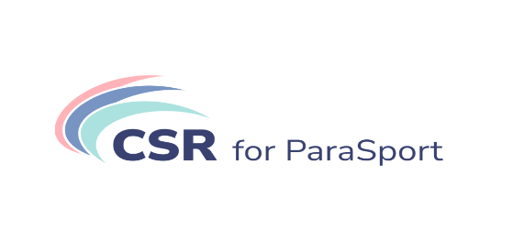

CSR for Parasport

INTERNATIONAL CONFERENCE
organized by the HUNGARIAN PARALYMPIC COMMITTEE

Wednesday, 22 February 2023, at 14:00 (CET)
ZOOM WEBINAR

14:00 Opening ceremony and welcome speeches
14:15 Para coach of the year 2022 Award ceremony
14:20 Awards ceremony of the Hungarian Paralympic Committee 2022
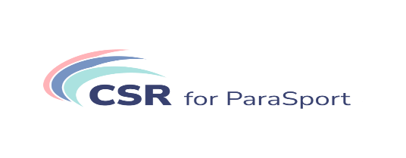

14:35 Presentations by Hungarian and foreign lecturers about

- Erasmus+ Project: CSR for Parasport
Presenter: Nikolina Markota Vukić, President - IDOP, Croatian Institute for CSR

- Allianz for Parasport
Presenter: Enikő Kónya-Prépost, Allianz Zrt, Senior Marketing Manager

- Together for common success for 17 years
Presenter: Mónika Lesti, K&H Bank Zrt, Senior Communications Manager

- Focus on integration – Hungarian National Lottery
Presenter: Ildikó Panulin, Szerencsejáték Zrt, Head of Corporate Communication Dept.

- Toyota – Mobility to everyone – Olympics and Paralympics
Presenter: Gábor Csikós, Marketing & Product Senior Manager Toyota Central Europe – Hungary

- Role of the International Paralympic Committee in CSR
Presenters: Nael Ogden-Smith, IPC, Director of Partnerships Services
Bart Schell, IPC, NPC Partnership Services Senior Manager

- CSR in Parasport, athlete’s pont of view
Presenter: Péter Boronkay, Paralympic triathlonist

16:00 Closing remarks

We can’t wait to join us!

Just click HERE!

